COMPARISON OF AGRONOMICAL AND PHYSIOLOGICAL NITROGEN USE EFFICIENCY IN THREE CULTIVARS OF WHEAT AS AFFECTED BY DIFFERENTLEVELS OF N-SOURCES.

Emad,M.Hafez ;S.H.Aboukhadrah; S.Gh.R.Sorour and A.R.Yousef
Agron. Dept., Fac. Agric., Kafrelsheikh Univ., 33516, Kafr El-Sheikh, Egypt

ABSTRACT
Efficient nitrogen (N) fertilizer management is critical for the improved production and nitrogen use efficiency of wheat(TriticumaestivumL.) and can be achieved through source and levels of N application. Thus, anexperiment was carried out at the Research Farm of the Faculty of Agriculture, Kafrelsheikh University, during 2007/08–2008/09 seasons to test the effects of sources and levels of N application on yield, yield components and nitrogen use efficiency of three wheatcultivars(Sakha94,Sakha93 and Giza168). Nitrogen sources were ammonium sulphate(NH₄SO₄) ,ammonium nitrate (NH₄NO₃) and urea (CO(NH₂)₂) applied at the levels(119,166 and 214 kg ha⁻¹). Sakha94 surpassed the other two varieties in all studied traits except spike length,grain weight per spike and 1000-grains weight whereas Giza 168 surpassed the other two varieties in these traits. Increasing N fertilizerlevels significantly increased all studied traits in both seasons. Grain yield/ha.wasincreased (6.10,6.45 and 6.79)in the 1st season and (6.64, 7 and 7.33) in the 2nd season due to increasing the levels of N from (119, 166 and 214kg N/ha). respectively, While, % apparent recovery N of fertilizer,agronomic NUE and physiological efficiency decreased with increasing N levels. Nitrogenaddition as ammonium sulphate showed a favorable significant effect in improving moststudied traits than ammonium nitrate and urea.The fertilizer N uptake showed that ammonium sulphate was a more available source of N for wheat than urea and ammonium nitrate.The maximum grain yield was achieved by 214 kg N/ha.as ammonium sulphate withSakha94.

Key words: Wheat, N sources, N levels and N use efficiency

INTRODUCTION

Wheat (TriticumaestivumL.) is considered to be the first strategic food crop in Egypt.Wheat is the most important grain crop for bread flour and straw crop for livestock feed in Egypt. It has maintained its position as the basic staple food in urban areas and mixed with maize in rural areas for bread making. In addition, wheat straw is an important fodder. Wheat a staple part of the diet in over 60 countries, being 10-20% of the daily calorific intake and unique in its ability to make breadSeleimanet al (2010).
Nitrogen (N), an essential element of the biochemical processesthat drives crop production (Sinclair and Horie, 1989). N fertilization plays a central role for achieving the highestyield in wheat in each particular environment, and a higher N useefficiency (NUE) is desired to protect ground and surface waters(Cassman et al., 2003).Nitrogen use efficiency indicates how effectively crops transformavailable N into grain yield, however, to assess the effects ofdifferent agronomic practices on this index, it is useful to analyzeseparately its main components. Typically, these components are (i) the recovery efficiency, i.e. the ratio between N uptake andapplied N, and (ii) the physiological efficiency, which reflects theratio between grain yield (or biomass) and N uptake. Thus, thisapproach includes different physiological processes that affect Nuse, asNuptake from the soil (Paponov et al., 1996).Likewise, numerous reports showed a declinein NUE when N fertilizer rates are increased (Timsina et al., 2001),Wheat N uptake was increased by 35% when one- quarter of the N was supplied as NH₄, compared with all N as NO₃ (Wang and Below, 1992). High-yielding wheat genotypes were unable to absorb NO₃during ear development, which limited yields otherwise increased by supplies of NH₄(Pan et al., 1984). Assimilation of NO₃ requires the energy equivalent of 20 ATP mol⁻¹ NO₃, whereas NH₄ assimilation requires only 5 ATP mol⁻¹NH₄(Salsac et al., 1987).Thus, the objective of this study is to study the effect of three levels of three nitrogen sources and three Egyptian cultivars on wheat yield, its attributes and N-uptake together with nitrogen recovery, agronomic and physiological nitrogen use efficiency andcrude protein content in grains.

MATERIALS AND METHODS
Two field experiments were carriedout in Experimental Farm of the Faculty of Agriculture, Kafrelsheikh University, during 2007/08 and 2008/09seasons. Effectof three nitrogen levelsfrom three N-sources ongrain N uptake, apparent recovery nitrogen fertilizer, agronomic and physiological NUE, yield and its components of threewheat cultivars.
The experimental soil was clay having analkaline reaction. Results of soil analysissamples collected before treatmentsapplication are reported in Table 1, and thepreceding crop was rice(Oriza Sativa, L) inboth seasons.

Table (1): The mechanical and chemical analysis of the experimental soil during the two seasons of study.
Variable | Season
Variable | 2007/2008 | 2008/2009
Mechanical analysis
Fine sand | 17 | 15
Silt | 35 | 36
Clay | 45 | 48
Soil texture class | clay | clay
Chemical analysis
Soil reaction(ph) | 7.8 | 7.9
Available N ppm | 31 | 34
Available P ppm | 19 | 18
Available K ppm | 272 | 204

Each experiment included 27treatments which were the combination ofthree wheat cultivars, three N rates and threesources of N fertilizer as follows:-
A- Wheat varieties :
1-Sakha94
2-Sakha93
3-Giza168
Grains of the three wheat cultivarswere secured every season from WheatResearch Section, Agricultural ResearchCenter (ARC), Giza. Egypt.
B- N- levels (kg/ha)
1- 119 kg N/ha
2- 166 kg N/ha
3- 214 kg N/ha
Nitrogen fertilizer was applied asbroadcast in three equal doses before the sowing ,the tilleringand the booting stages.
C- Nitrogen sources:
1-Urea (CO (NH₂)₂, 46.5% N).
2-Ammonium sulphate (NH₄SO₄,20.5% N)
3-Ammonium nitrate (NH₄NO₃, 33.5 % N)
Treatments were replicated fourtimes in the strip split-plot in a randomizedcomplete block design. The three cultivarswere allocated to the horizontalplots, the threeN levels were randomly distributed in thevertical plots, while the three N sources wereallocated at random to the sub-sub plots.Plot size was 10.5 m² (3 x 3.5) including20 rows 15 cm apart and 3.5 meter length.Sowing date was 1st and 8th of December in the first and second seasons,respectively. Phosphorus fertilizer wasadded before sowing during landpreparation as Calcium super phosphate(15.5 % P₂O₅) at the rate of 300 kg /ha.Weeds thatgerminated subsequently were removed byhand.The other recommended agronomicpractices of growing wheat were applied inthe manner prevailing in the region.The following yield and yield
attributes were recorded:At harvest, plants in one squaremeter were harvested to determine thefollowing traits:
1- Plant height (cm)2- Spike length (cm)
3- Number of spikelets/spike4- Number of grains/spike
5- Grain weight per spike (g)6- 1000-grain weight (g)
7- Grain yield (ton/ha) 8- Grain protein content(%)
9-Straw yield(ton/ha)10-Biological yield(ton/ha)
11-Harvest index(%) calculated as following grain yield/grain yield+straw yield
12-Grain nitrogen uptake (kg/ha)
13-Apparent nitrogen recovery of fertilizer(%)
14-Agronomic nitrogen use efficiency(kg grain yield/kg N applied)
15-Physiological efficiency(kg ha⁻¹ grain N uptake)
Statistical analysis:
Data were analyzed with analysisof variance (ANOVA) procedures according to Gomez and Gomez (1984) usingthe MSTAT-C Statistical Softwarepackage.Where the F-test showedsignificant differences among meansDuncan’s multiple range test (1955) wasperformed at the 0.05 level of probabilityto compare between means.

RESULTS AND DISCUSSIONS
I .Some yield attributes:-
Varietal differences:
Data in Table (2) showed that the three wheat cultivars significantly differed in plant height, spike length, spikelet number/spike, spikes number m⁻², grain number/spike, grain weight/spike and 1000-grain weight.Sakha94 wheat cultivar showed superiority in these traits. The three tested cultivars could be arranged in a descending order as follows: Sakha94, Sakha93 and Giza168. This may be attributed to the differences among studied varieties in yield genetical constitution. The results of varietal differences in the above studied traits are in agreement with those reported by Seleimanet al (2010) who found that the tested wheat cultivars Sakha93 and Giza168 showed significant difference in all characters studied.

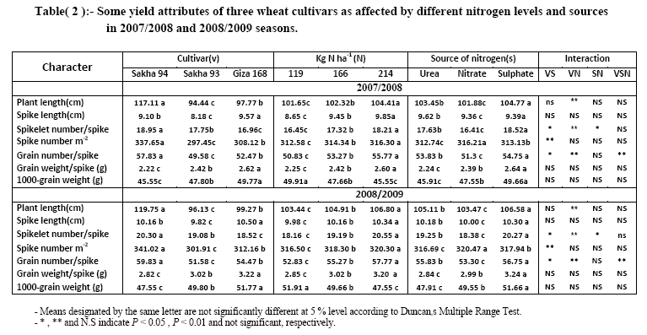

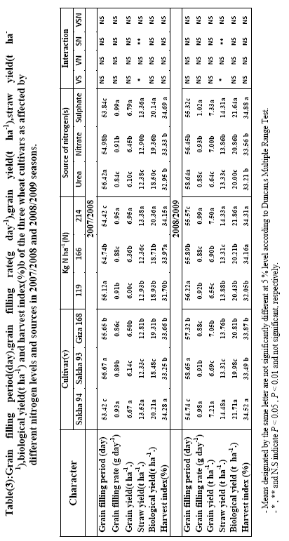

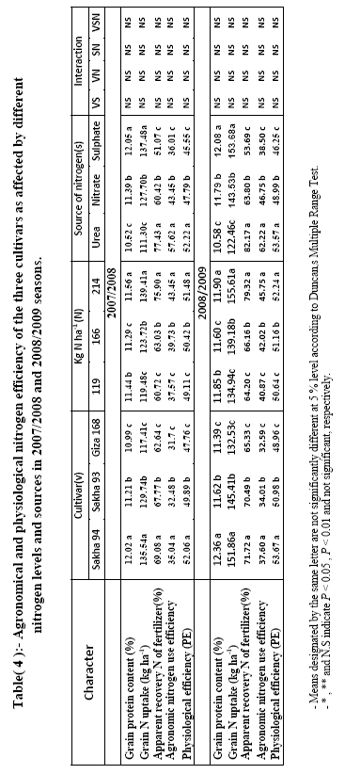

Data presented in Table (2, 3 and 4) showthe effects of rates and sources of nitrogenfertilizers on Nitrogen Use Efficiency(NUE), yield and its components of threewheat varieties.

Nitrogen levels
The data presented in Table (2)show that all studied traits except 1000-grain weight were significantly increased withincreasing N fertilization levels.The higherN level (214 kg N/ha) was more effectivein increasing all studied traits. Nitrogen at214 kg N/ha produced the maximum results and proved significantly superior tolower levels. Thefavorable effect of N fertilization on plantheight and number of spikes/m² which areassociated with number of tillers/plant mayexplain the role of nitrogen in stimulatingcell division and elongation, consequentlyinternodes elongation in addition anddevelopment. However, the role of N inencouraging metabolic processes in wheatplants, consequently their growth, spikeinitiation and grain filling is responsiblefor the increase of spike length, number ofspikelets and grains/spike, 1000-grain weight and ultimately grain yield/ha.Similar results were obtained by Sadur and Khalil (2010).

Nitrogen sources:-
Regardless of wheat cultivars data in Tables (2) showed that there weresignificant differences between N fertilizer sources inall characters under study. It isclear that ammonium sulphate (NH₄SO₄,20.5% N) exceeded significantly the other sources followed by ammonium nitrate and at last urea.The highest yield for ammonium sulfate applied may have been associated with better N use efficiency (Garnicaet al. 2010). It could be a result of reduced N losses from volatilization in low temperature.This finding may be explained by the fact that (NH4)₂SO₄ as N-form decreases soil pH, which might favor elements availability and uptake by plants in slightly alkaline soils (Guelser 2005).

Interaction:
The data showedsignificantly difference for the interaction betweenwheat cultivar and nitrogen level for plant height, spikelet number/spike and number ofgrains/spike in bothseasons and the interaction between wheat cultivar and N source for spikelet number/spike, spike number m⁻² , grain number/spike andstraw yield and the interaction between N source and N level for spikelet number/spike andstraw yield and the interaction among wheat cultivar , N source and N level for grain number/spike .These results indicate that thethree wheat cultivars responded differentlyto nitrogen fertilization levels and sources.It wasnoticed that increasing the N levels from 119to 214 kg/ha stimulated these traits, andSakha94 was the best cultivar under214 kg N/haof ammonium sulphate.

II- Grain and straw yield:-
Varietal differences:
Data in Table (3) showed that the three wheat cultivars significantly differed in grain filling rate, grain yield, straw yield, biological yield and harvest index.Sakha94 wheat cultivar showed superiority in these traits. The three tested cultivars could be arranged in a descending order as follows: Sakha94, Giza168 and Sakha 93. The results of varietal differences in the above studied traits are in agreement with those reported by Seleimanet al (2010) who found that the tested wheat cultivars Sakha93 and Giza168 showed significant difference in all characters studied.

Nitrogen levels
The application of 166 and 214 kg N /ha increased the grain yield over the 119 kg N / ha by6and 11% in the 1st season and by 5.5 and 9.9 % in the 2nd season Table (4).When N fertilizer is applied at levels greater than required for maximum yield, plant biomass and long term soil organic C increase (Raun et al., 1998), but NUE decreases.
Nitrogen sources:-
Regardless of wheat cultivars data in Tables (3) showed that there weresignificant differences between N fertilizer sources inall characters under study. It isclear that ammonium sulphate (NH₄SO₄,20.5% N) exceeded significantly the other sources followed by ammonium nitrate and at last urea.The highest yield for ammonium sulfate applied may have been associated with better N use efficiency (Garnicaet al. 2010). It could be a result of reduced N losses from volatilization in low temperature. This finding may be explained by the fact that (NH4)₂SO₄ as N-form decreases soil pH, which might favor elements availability and uptake by plants in slightly alkaline soils (Guelser 2005).

Interaction:
The interaction between N source and N level for straw yield and the interaction among wheat cultivar , N source and N level for grain number/spike .These results indicate that the three wheat cultivars responded differently to nitrogen fertilization levels and sources.It was noticed that increasing the N levels from 119 to 214 kg/ha stimulated these traits, and Sakha94 was the best cultivar under 214 kg N/haof ammonium sulphate.

III- Nitrogen use efficiency:-
Varietal differences:
Data in Table (4) showed that the three wheat cultivars significantly differed in
grainprotein content, grain N uptake, apparent recovery N of fertilizer, agronomic nitrogen use efficiency and physiological efficiency. Sakha94 wheat cultivar showed superiority in these traits. The three tested cultivars could be arranged in a descending order as follows: Sakha94 Sakha 93 and Giza 168.The results of varietal differences in the above studied traits are in agreement with those reported by Seleimanet al (2010) who found that the tested wheat cultivars Sakha93 and Giza168 showed significant difference in all characters studied.

Nitrogen levels
The agronomic and physiological NUE reached a maximum of (57.62 , 52.22)and (62.22 ,53.57) kg grains/kg N applied in the 1st and 2nd seasons, respectively, when N was applied at 119 kg N/ha (Fig.4). The application of high nitrogen levels may result in high grain N uptake and low agronomic and physiological NUE due to excessive N losses and decreased N utilization efficiency.Further investigations are needed to study theefficient use of other nitrogen levels.Faizyet al. (2010) found that NUE decreased by increasing N-level up to 140 kg/fed. Aynehband(2010) found that low NUE at higher N level can be attributed to losses from NH₃volatilization,denitrification,leaching and N loss from the wheat plant.Recovery of N applied at planting ranged from 30 to 55% while that applied at anthesis ranged from 55 to 80% (Wuest and Cassman, 1992a). Some benefits are associated with practices that have low NUEs. Increasing the N rate where lower rates are applied will increase crop production, especially in the developing world (Hardy and Havelka, 1975); however, if not combined with recommended management practices, this will decrease NUE. Increasing soil organic C when high N rates are used could assist in removing the excess atmospheric CO₂ widely believed to be responsible for global warming (Smit et al., 1988), but are likely to increase N losses via denitrification(Aulakh et al., 1984).

Nitrogen sources:-
Regardless of wheat cultivars data in Tables (4) showed that there weresignificant differences between N fertilizer sources inall characters under study. It isclear that ammonium sulphate (NH₄SO₄,20.5% N) exceeded significantly the other sources followed by ammonium nitrate and at last urea.The highest yield for ammonium sulfate applied may have been associated with better N use efficiency (Garnicaet al. 2010). It could be a result of reduced N losses from volatilization in low temperature.This finding may be explained by the fact that (NH4)₂SO₄ as N-form decreases soil pH, which might favor elements availability and uptake by plants in slightly alkaline soils (Guelser 2005).

CONCLUSION

Our results suggested that ammonium sulfate more effectively increases grain yield, agronomic and physiological NUE than urea and ammonium nitrate in spring wheat cultivars under well irrigated conditions. Egyptian cultivar as Sakha94 can bare higher spikelet number and spikes than Sakha93 and Giza168 to increase grain yield, agronomic and physiological NUE furthermore,higher biomass to Sakha94 than other cultivars.

REFERENCES
Aulakh, M.S. andS.S. Malhi(1984). Fertilizer nitrogen use efficiency as influencedby interactions with other nutrients. In: Mosier, A.R., Syers, K.J., Freney, J.R.(Eds.), Agriculture and the Nitrogen Cycle. Island Press, Washington,USA,pp. 181–191.

Aynehband, A.; A. A. Moezi and M. Sabet (2010).Agronomic assessment of grain yield and nitrogen loss and gain of old and modern wheat cultivars under warm climate. African Journal of Agricultural Research, 5 (3) : 222-229, 4 February.
Cassman, K.G.;A.Dobermann andH.Yang(2003).Meeting cereal demandwhile protecting natural resources and improving environmental quality.Annual Review of Environment and Resources 28, 315–358.
Duncan, B.D. (1955).Multiplerangeand multiple F.Test.Biometrics,11:1-42.
Garnica, M.; F. Houdusse; A. M. Zamarre and J. M. Garcia- Mina (2010) Nitrate modifies the assimilation pattern of ammonium and urea in wheat seedlings J Sci Food Agric; 90: 357–369.
Gomez, K.A. and A.A. Gomez (1984).Statistical procedures for agricultural research. Wiley Interscience, New York, 680 p.
Guelser, F. (2005). Effects of ammonium sulfate and urea on NO₃− and NO₂− accumulation, nutrient contents and yield criteria in spinach. Sci. Hort.,106:330–340.
Hardy, R.W.F. and U.D. Havelka(1975). Nitrogen fixation research: A key to world food? Science (Washington, DC) 188:633–643.
Faizy, S. E-D. A.; M. M. Rizk; M. M. Ragab and M.M. A.Amer(2010).Response of wheat yield and apparent nitrogen recovery of fertilizer to mineral nitrogen and biofertilizer application in salt affected soils.J.Agric. Res. Kafr El-Sheikh Univ., 36 (1) 74-96.
Pan, W.L.; E.J. Kamprath.; R.H. Moll and W.A. Jackson(1984). Prolificacy in corn: Its effects on nitrate and ammonium uptake and utilization. Soil Sci. Soc. Am. J. 48:1101–1106.
Paponov, I.;W.Aufhammer andF. P. Ehmele(1996).Nitrogen efficiency components of winter cereals.European Journal of Agronomy 5, 115–12.
Raun, W.R.; G.V. Johnson.; S.B. Phillips and R.L. Westerman (1998).Effect of long-term N fertilization on soil organic C and total N in continuous wheat under conventional tillage in Oklahoma. Soil Tillage Res. 47:323–330.
Salsac, L.; S. Chaillou.; J.F. Morot-Gaudry.; C. Lesaint and E. Jolivoe(1987).Nitrate and ammonium nutrition in plants. Plant Physiol. Biochem. 25:805–812.
Sadur R.; S. K. Khalil; F. Muhammed and I. H. Khalil(2010).Phenology, leaf area index and grain yield of rainfed wheat influenced by organic and inorganic. Pak. J. Bot.,42(5): 3671-3685.
Seleiman, M. F. and S. M. Abdel-Aal (2010).Variation of yield, milling,technological and rheological characteristics in some Egyptian bread wheat (TriticumaestivumL.)cultivars. Emir. J. Food Agric., 22 (2): 84-90.
Sinclair, T.R. and T.Horie (1989). Leaf nitrogen, photosynthesis, and crop radiation use efficiency: a review. Crop Science 29, 90–98.
Smit, B.; L. Ludlow and M. Brklacich.(1988). Implications of a global climatic warming for agriculture: A review and appraisal. J. environ. Qual. 17:519–527.
Timsina, J.;U.Singh.;M.Badaruddin.;C.Meisner andM.R. Amin (2001).Cultivar,nitrogen, and water effects on productivity, and nitrogen-use efficiency andbalance for rice–wheat sequences of Bangladesh.Field Crops Research 72,143–161.

Wang, X. and F.E. Below (1992). Root growth, nitrogen uptake, and tillering
of wheat induced by mixed-nitrogen source. Crop Sci. 32:997–1002.
Wuest, S.B. and K.G. Cassman(1992a). Fertilizer-nitrogen use efficiency of irrigated wheat: I. Uptake efficiency of preplant versus late-season application. Agron. J. 84:682–688.

الملخص العربى

مقارنة كفاءة استخدام النتروجين الفسيولوجية والمحصولية لثلاثة أصناف من القمح
تحت تأثير مستويات مختلفة من مصادر السماد النتروجينى

عماد الدين ماهر حافظ, سعد حسن أبو خضره , صبحى غريب رزق , عادل يوسف رجب
قسم المحاصيل-كلية الزراعة- جامعة كفرالشيخ.33516 كفرالشيخ مصر

استهدف هذا البحث دراسة تأثير مستويات مختلفة منمصادرالسماد الأزوتى على بعض الأصناف عالية الانتاجمن محصول القمح وذلك خلال موسمى الزراعة 2007/2008 و2008/2009 وقد أجريت هذه الدراسة فى المزرعة البحثيةلكلية الزراعة – جامعة كفر الشيخ- مصر.أجريت الدراسة على ثلاثة أصناف من قمح الخبز هم (الصنف سخا 94 و الصنف سخا 93والصنف جيزة 168)وكانت معدلات التسميد الأزوتى (50-70-90 كجم أزوت/فدان)والتى يعادل (119-166-214 كجم أزوت / هكتار) لكل مصدر من الثلاث مصادر النتروجينىية (يوريا 46.5%و سلفات الامونيوم20.5% ونترات الامونيوم33.5%) وقداستخدمت القطع المتعامدة مرتين ذات أربعة مكررات حيث خصصت القطع الرئيسية الأفقية للأصناف والقطع الرئيسية الرأسية لمصادر النتروجين والقطع المنشقة لمستويات السماد النتروجينى.
وتتلخص أهم النتائج على النحو التالى:-

- اختلفت الاصناف تحت الدراسة معنويا حيث تفوق الصنف سخا94 عن باقى الأصناف فى كمية المحصول.
- كان هناك زيادة معنوية نتيجة زيادة معدلات التسميد النتروجينى حتى 214 كجم/ هكتار على المحصول ومكوناته المدروسة ومحتوى الحبوب من النتروجين وكذلك الممتص منه فى حين ان زيادة معدلات السماد النتروجينى الى انخفاض وزن الالف حبة وكذلك كفاءة استخدام النتروجين المحصولية والفسيولوجية.
- أدى إضافة السماد النتروجينى على صورة سلفات الامونيوم إلى زيادة معنوية إلى المحصول ومعظم مكوناته وكفاءة استخدام النتروجين المحصولية والفسيولوجية وكذلك كمىة النتروجين الممتص ونسبة ظهور وتكشف سماد النتروجين.
- وجدت تأثيرات معنوية للتفاعل بين الأصناف ومستويات السماد النتروجينى على طول النبات وعدد السنيبلات للسنبلة وعدد الحبوب للسنبلة. وكذلك التفاعل بين الأصناف ومصدر السماد النتروجينى على عدد السنيبلات للسنبلة وعدد السنابل /م² وعدد الحبوب للسنبلة ومحصول القش. وكذلك التفاعل بين مصدر السماد ومستوياته على عدد السنيبلات للسنبلة وومحصول القش. وكذلك التفاعل الثلاثى بين الأصناف ومصدر السماد ومستوياته على عدد الحبوب للسنبلة فى كلا موسمى النمو.

