PHENOTYPIC AND GENOTYPIC STABILITY FOR SOME SUGAR BEET GENOTYPES

EL-Refaey*,R.A.;E.H.EL-SEIDY*;I.H.EL-Geddawy** and H.M.EL-Sayed**
*- Agron. Dept .Fac. Agric. Tanta Univ.
**- Sugar Crops REs. Inst.(SCRI) , Agric. Res. Centre (ARC)

Abstract

Two field experiments were conducted in two successive seasons of 2004/05 and 2005/06 at tow locations (Belkas, Dakahlia governorate and Sakha, kafr El- Sheikh ). Each trial included twelve sugar beet varieties . Genotypic and phenotypic stability studies were done on the root yield of sugar beet at harvest. The collected results showed that:
*- Wide range of environmental index for root yield ranged from -3.90 to +2.67 which indicated significant variation between environments. However, Kawemera variety had the widest rang of environmental index (-5.77 to +3.82), while Sofi variety had the closest one (-2.88 to +2.58).
*- The environmental indices were negative for all environments which untreated with Set or Nitrate compounds at two locations in both seasons, while the environmental indices were positive for all environments treated with either Set or Nitrate compounds at Kafr El-Sheikh location .
*- The environments were the most important source of variation, explaining (94.9%) of the variance in root yield , followed by the genotypes (3.58 %) and the interaction of genotypes x environments (1.52 %).
*- The linear proportion of variance was 99.63 % from the total variance.
*- The b_{i} statistics were significant for the varieties namely Marathon, Univers, Invermono, Sofi, Helma, Montipianco, Athospoly and Del 937. Univers, Sofi, Montipianco and Del 937 varieties had (b_{i}) values of 1.302, 2.398, 1.541 and 2.611, respectively, indicating higher production potential in favourable environments. On the other hand , Marathon , Invermono and Athospoly varieties had (b_{i}) values of 0.657, - 0.612 and 0.272 , respectively , which appeared to be more adapted to poor environments.
*- Del 936 and Sultan varieties had better stability and broader adaptability than the others tested from the phenotypic stability point of view .
*- Del 936 and Sultan varieties are desirable varieties because its mean yield are high, its α_{i} values are zero and its deviation from linearity ( 0.079 and
– 0.029 ) stability from genotypic stability point of view.

INTRODUCTION :
Sugar beet ( Beta vulgaris L.) ranks as the world's second most important sugar crop. It is generally adapted to producing high yields under less favorable ecological conditions than that is required for sugar cane crop. Under the limit water resources increasing the cultivated area from sugar cane horizontally became illogically. To face the continuous demand on sugar and to decrease the gap between the local sugar production and the consumption it could be necessary to approach from the new recommended agricultural practices which affected on yield and quality of sugar crops. More over increasing the cultivated area from sugar beet is one of acceptable solution for this period ,especially that crop distinguished by low needed of water and succeeded under the new reclaimed area . This investigation was carried out to study the effect of some genotypes and environments on yield and its components of some sugar bet varieties. Stability parameters is one of the important measurements that have direct effects on production in the aspects of the quantitative and qualitative components . Varieties production great depends on the prevailing genetic potential expression and ecological environments around the plant .
Allard and Bradshaw. ( 1964 ) classified the environmental variations into two classes; predictable and unpredictable variations. The predictable category included planting dates, day length, method of harvest, soil type and major location features. The unpredictable category included fluctuations in temperature and rainfall. The interaction between genotype x year was included in the second category, while the interaction between location and genotypes was included in the first class. Significant variety x location would suggest breeding for the specific environment. For the interaction of year x genotype, it would be hard to breed certain genotype for each year. The only solution for latter type would be through developing stable varieties. They recommended that the ideal stable variety would show a low genotype x environment interaction. Eberhart and Russel ( 1966 ) examined the data collected from two single-cross diallels and a set of three-ways crosses by regression analysis in maize. They defined the stable variety as that which had (1) b=1 (regression coefficient),(2) S2d=0(deviation from regression near zero) and (3) had high yielding ability. Their analysis attempted to determine the linear response of a variety to the environment effects. Based on the principal of structural relationship analysis, the genotype-environment interaction effect of a variety is partitioned into two components. They are the linear response to environmental effects, which is measured by a statistic alpha(alpha),and the deviation from the linear response, which is measured by another statistic lambada. Tai ( 1971 ) reported that a perfectly stable variety has ( alpha and y
1, -1 = ( and a variety with average stability has (alpha and y
) = 0.1( .Seedlings in three series of potato main crop regional trials were analyzed for the genotypic stability of their marketable tuber yield. The results showed that the highest yields were unstable, while the seedlings with average stability had about the same yielding ability as the check varieties. Tripathi and Srivastava ( 1978 ) tested 16 genotypes at different locations. Genotype x environment interaction was significant for root and sugar yields. Romons Kaya 60 was a good yielded with average stability. Maribo Magnapoly , Kawe Megapoly and Kawe Gigapoly gave higher sugar yields than other genotypes. Sanbuichi et al. ( 1981 ) evaluate several varieties at six sites. Hokkai 41 showed the greatest stability for root yield, sugar content and sugar yield. Monohill showed stability for sugar yield alone. Korneeva et al. ( 1987 ) tested 11 breeding lines under 6 ecologicaly different growing conditions. In Yaltushkovskaya ( monogerm ) and Ramonskaya-6 ( multigerm ) root yield and sugar content were significantly affected by environment x year interaction but not by environment x genotype or year x genotype interactions, indicating that they had high ecological stability. Ecological conditions accounted for 83.2-95.4% of variation in yield and 95.6-98.6 % of variation in sugar content among the genotypes. Significant differences between genotypes were observed in all years except 1981 and 1984 for yield but only in 1982 for sugar content. Gyllenspetz ( 1988 ) reported that root yield and sugar yield showed a very low genotype-environment interaction. Content of sugar, higher dependence on environmental influence. Potassium, sodium and alfa-amino nitrogen showed greater interactions with environment than yield traits, the stability parameters regression coefficient .There was a trend for higher yielding varieties to be more unstable than moderately yielding varieties; they were more responsive to high yielding locations. High yielding varieties with very good stabilities were identified . It is suggested that a limited number of highly representative locations should be found within the relevant geographic area. Ghandorah and Refay. (1994 (evaluated 4 sugar beet cultivars at 8 environments (4 sowing dates and 2 years). They found no important significant interactions for cultivar x year, cultivar x sowing date and cultivar x sowing date x year, indicating the stability of the four cultivars under different environments. Piepho ( 1995 ( stated that stability analysis of multi location trials is often based on a mixed 2-way model. Two stability measures in frequent use are the environmental variance, (Si²) and the ecovalence (Wi). Under the two-way model the rank orders of the expected values of these 2 statistics are identical for a given set of genotypes. By contrast, empirical rank correlations among these measures are consistently low. This suggests that the two-way mixed model may not be appropriate for describing real data. To check this hypothesis, a Monte Carlo simulation was conducted on data from trials of oats, oilseed rape, sugar beet, fodder beet and faba bean. It revealed that the low empirical rank correlation among Si² and Wi is most likely due to sampling errors. It is concluded that the observed low rank correlation does not invalidate the two-way model. The paper also discusses tests for homogeneity of Si² as well as implications of the two-way model for the classification of stability statistics.. Denis et al. ( 1997 ) presented an integration of two types of models for the analysis of genotype x environment interaction. On the one hand, the expectation of G x E interaction is frequently modeled by regression models; on the other hand, for deviations from these regressions, either separate stability parameters are defined or extra components of variance are introduced. A class of mixed models is described that contains facilities for modeling expectation by regression and, in addition, has extensive possibilities for dealing with hetero scedasticity. Practical aspects of the use of these mixed models are illustrated on a data set involving sugar yield in sugar beet infected by beet necrotic yellow vein furovirus.. Liovic and Kristek ( 2000 ) evaluated seventeen sugar beet genotypes for stability of yield components at 3 locations ( Osijek, Dakovo,
Magadenovac ) . Ecovalence (Wi), coefficient of regression (bi) and deviation mean squares (ssuperscript 2dt) were calculated using biometrical methods. Genotypes of high yield stability were: Kristal, Jela and Rita for root yield; Os Ana, Kawemaja, Marika and Jela for sugar content; Dunja, Jela, Kristal and Marika for sugar recovery; and Jela, Barbara, Dunja and Kristal for white sugar yield. Correlation coefficients (r) for root and white sugar yield, show existence of high significant and positive correlation among mean and bi, and among superscript 2dt and Wi.. El-Hinnawy et al. ( 2003 ) evaluated phenotypic stability for yield, yield components and juice quality was evaluated in 13 sugar beet cultivars grown at four locations (Giza, Sakha, El-Mansoura and El-Fayoum) in Egypt during 1998 under two planting dates (15 October and 15 November). Significant genotype x environment interaction was recorded for extractable sugar yield, root yield, total soluble solids, sucrose percentage and purity. The stable cultivars consisted of Farida and Del 939 for extractable sugar yield; Alexa for total soluble solids; Marathon, Panther, Lola, Farida and Kawemira for sucrose percentage; and Marathon, Farida and Oscarpoly for purity. Hoffmann and Marlander ( 2005 ) studied effect of genotype and environment on the composition of total soluble N in sugar beet and to evaluate whether amino N reliably represents the total soluble N. For this purpose, beet brei of 57 genotypes grown at 22 sites in 2000/2001 was analyzed for total soluble N, amino N, betaine, nitrate, and amino acid composition. The composition of total soluble N was more affected by environment than by genotype, whereby amino N was the only component which changed considerably. The effect of genotype followed the same pattern as the impact of environment. Genotypes showed a high environmental stability for the percentage of amino N. For environments as well as for genotypes, low amino N was compensated by relatively higher betaine and vice versa. It is concluded that amino N is an acceptable estimate for total soluble N because of the close and consistent relationship across environment and genotype. However, the quality assessment of sugar beet might even be improved by including betaine or total soluble N in addition to the standard parameters.
MATERIALS AND METHODS :
Three separately experiments conducted in 2004/05 season and repeated in 2005/06 season at tow locations (Belkas, Dakahlia governorate and Sakha, kafr El- Sheikh ) in each season.. Twelve sugar beet varieties were evaluated in each experiment . A list of these varieties and the country of the origin is presented in table ( 1 ). Each experiments was arranged in a randomized complete block design (RCBD) with four replicates . Plot area was 21 m² where each plot consists of six rows and 0.5 m between rows . Sowing dates were done on the 1st week of October in the two seasons at the two locations .Nitrogen fertilizer was applied at 80 kg N/fed as the form of urea (46%N) in two equal doses , the first one after thinning "at 4 leaves stage" and the second dose was added one month later .Phosphorous fertilizer (20 kg P₂ O₅ /fed) was applied as calcium super phosphate ( 15.5% P₂O₅ ) during the bed preparation, Potassium fertilizer ( 24 kg K₂O/fed ) as potassium sulphate (48 % K₂O) was added after thinning with the 1st dose of nitrogen. All cultural practices for growing sugar beet were done as recommended in the area . Harvesting date was done after 7 months.
Data recorded:
At harvest , plants of the four guarded rows were taken from each plot to estimate root yield ( ton / fed ).
Homogeneity test of variance was computed by Bartlette's methods (1937) .For combined analysis , it was assumed that the error variance for all locations was homogenous. The form of the combined analysis over seasons and locations and the expectations of mean squares are found in tables inside the text .It would be expected that the sources of variations of locations, seasons and genotypes had fixed effect because the ranking of each of the best sugar beet genotypes and the favorable year and location will be taken into considerable .
Specific statistical analysis study:
Stability methods:
Several investigators suggested various methods to measure stability parameters, using the original data of root yield per plot for the two sugar beet experiments . These methods had been widely used in previous investigations in different crops . Most of them depended on regression techniques, either phenotypic or genotypic stability. These methods were :
- Eberhart and Russell method (1966).
2. Tai method (1971).
Thus, these analysis methods can be compared on the basis of their return in terms of the information yielded for the same outlay in terms of the work involved . However , Eberhart and Russell method (1966) was used measure phenotypic stability, While Tai method (1971) was used to measure genotypic stability.
Table ( 1 )
Varieties And Its Classification
No. | Varieties | Type* | Geno-type | Origin
1 | Marathon | E | Mono-germ | ( Danisco) Denmark
2 | Univers | E | Mono-germ | (Van der have) Holand
3 | Invermono | N | Mono-germ | (Kuhn) Holand
4 | Sofi | N | Mono-germ | ( Syngenta) Sweden
5 | Del 936 | Z | Mono-germ | (Delitzsch) Germany
6 | Helma | Z | Mono-germ | ( Syngenta) Sweden
7 | Kawemera | E | Multi-germ | ( KWS) Germany
8 | Montipianco | E | Multi-germ | (Delitzsch Germany
9 | Athospoly | N | Multi-germ | (Kuhn) Holand
10 | Del 937 | N | Multi-germ | (Delitzsch) Germany
11 | Del 938 | Z | Multi-germ | (Delitzsch) Germany
12 | Sultan | Z | Multi-germ | (Van der have) Holand
*
E- type = charachteristic by high root yield and low sugar percentage.
N- type = charachteristic by modirate root yield and sugar percentage.
Z- type = charachteristic by low root yield and high sugar percentage.

Table (2) Monthly Meteorological Parameters Of Locations And Seasons
Month | Temperature ⁰C |  |  |  | Relative humidity % |  |  |  | Soil temperature ⁰C depth 20 cm |  |  |  | Total rain fall (mm)
Month | 2004/ 05 |  | 2005/06 |  | 2004/05 |  | 2005/06 |  | 2004/05 |  | 2005/06 |  | 2004/05 | 2005/06
Month | Max | Min | Max | Min | Max | Min | Max | Min | Max | Min | Max | Min
Kafr El Sheikh
Oct. | 30.2 | 19.2 | 28.5 | 18.2 | 97 | 46 | 95 | 47 | 21.7 | 20.4 | 21.8 | 19.9 | _ | _
Nov. | 25.7 | 16.7 | 24.4 | 14.7 | 95 | 48 | 95 | 46 | 17.0 | 15.9 | 16.3 | 14.8 | 15 | 7
Des. | 20.8 | 11.9 | 21.1 | 12.1 | 97 | 53 | 95 | 55 | 11.9 | 11.0 | 12.9 | 11.6 | 50 | 8
Jan. | 19.0 | 9.6 | 18.7 | 9.9 | 93 | 52 | 95 | 53 | 9.9 | 8.8 | 10.2 | 8.8 | __ | 84
Feb. | 19.1 | 9.3 | 20.5 | 11.1 | 95 | 48 | 95 | 57 | 13.2 | 8.9 | 12.8 | 8.9 | 70 | 16
March | 22.6 | 10.8 | 23.0 | 11.4 | 96 | 45 | 93 | 48 | 14.6 | 13.3 | 15.6 | 13.5 | 17 | 17
April | 25.2 | 14.2 | 26.3 | 16.4 | 95 | 39 | 94 | 48 | 17.8 | 16.2 | 20.1 | 17.6 | 11 | 19
May | 29.0 | 17.8 | 29.0 | 18.6 | 95 | 40 | 95 | 47 | 21.8 | 20.1 | 24.4 | 21.3 | __ | __
June | 29.9 | 21.8 | 31.5 | 23.2 | 95 | 50 | 94 | 52 | 24.8 | 23.1 | 28.1 | 24.8 | __ | __
Dakahlia
Oct. | 30.5 | 17.7 | 27.2 | 15.6 | 97 | 35 | 94 | 35 | 27.7 | 26.4 | 24.9 | 23.1 | __ | __
Nov. | 26.0 | 16.3 | 24.1 | 12.5 | 97 | 40 | 94 | 36 | 17.3 | 15.7 | 25.4 | 23.4 | 11 | 7
Des. | 20.2 | 11.0 | 20.1 | 10.7 | 94 | 52 | 89 | 50 | 21.3 | 19.9 | 21.5 | 20.5 | 15 | 5
Jan. | 19.0 | 9.0 | 18.6 | 7.7 | 91 | 40 | 95 | 43 | 19.5 | 17.8 | 21.7 | 19.9 | 12 | 4
Feb. | 19.4 | 8.1 | 20.0 | 8.8 | 91 | 37 | 95 | 40 | 21.9 | 20.0 | 22.3 | 19.3 | 11 | 6
March | 22.1 | 10.1 | 22.8 | 10.3 | 94 | 34 | 95 | 34 | 14.1 | 12.0 | 21.4 | 18.8 | 8 | 7
April | 25.8 | 13.1 | 26.6 | 13.6 | 95 | 30 | 95 | 29 | 27.4 | 25.5 | 25.2 | 23.5 | 5 | 4
May | 30.9 | 16.0 | 29.5 | 15.1 | 96 | 25 | 97 | 26 | 23.2 | 20.5 | 21.1 | 19.2 | __ | __
June | 31.7 | 19.9 | 32.9 | 19.7 | 96 | 35 | 98 | 33 | 26.3 | 23.9 | 23.4 | 21.4 | __ | __
Source: Central laboratory for agricultural climate, Agricultural Research Center, Giza, Egypt.
Results and discussion
Phenotypic and genotypic stability:
The data presented in Table ( 3 ) revealed that mean root yield of 12 sugar beet varieties varied among environments and ranged from 19.03 ton/fed. for the environment 7 to 25.6 ton /fed for the environments 5 and 6.
The wide range of environmental index ( I ) for root yield (-3.90 to + 2.67) indicated significant variation between environments. The environmental index covered a wide range and displayed a good distribution within the range. Therefore, the assumption for stability analysis is fulfilled (Mather and Calgari, 1974 and Becker and Leon, 1988). The same results could be observed with respect to Marathon, Kawemera, Athospoly and Del 937 varieties which considered as the most desired varieties occupies the most areas cultivated by high production sugar beet varieties. However, Kawemera variety had the widest rang of environmental index (-5.77 to + 3.82) , while Sofi variety had the closest one (- 2.86 to + 2.58) as shown in Table (3).
The environmental indices were negative for all environments which untreated with either Set compound or Nitrate compound at two locations in both seasons . This would indicate that the untreated plants a less favorable condition for root yield production of sugar beet. On the other hand, the environmental indices were positive for all environments treated with either Set or Nitrate compounds at kafr El-sheikh location in both seasons, indicating the favorable condition of that treatments for high yielding ability of the crop. These results confirmed by many researcher’s among them; Denis et al. (1997).
The combined analysis of variance (Table 4) showed that the mean squares of environments, genotypes and their interactions were highly significant (p< 0.01).
The environments were the most important source of variation, explaining 94.9% of the variance in root yield, followed by the genotypes (3.58%) and the interaction of the genotypes x environments (1.52%) . The large environments mean square showed that the influence of environmental effects on mean root yield is more important than the mean differences in genotypes one and by far greater is important than (ExG) interaction. However, the significant of environments mean square provide a sufficient range of environments used, and hence validating the environmental requirements suggested by Eberhart and Russell (1966).
The presence of genotype x environment interactions indicates that certain genotypes tended to rank differently in root yield at different environments.
Analysis of variance for phenotypic stability (Table 4 ) revealed that linear component of variation was highly significant for root yield/fed, indicating that the differences among the regression coefficients pertaining to various sugar beet genotypes on the environmental mean were real. The linear proportion of variance was 99.63 % from the total variance (linear and non linear components). This would indicate that the major component of differences in stability was due to the linear regression and not to the deviation from that linearity. Therefore, the predications of genotype x environment interactions based on linear regression will have a considerable practical value.
These results were in accordance with those reported by Gyllenspetz (1988) , Liovic and Kristek (2000) and Chloupek and Hrstkova (2005).
The bi statistics were significant for Marathon, Univers, Invermono, Sofi, Helma, Montipianco, Athospoly and Del 937 genotypes ( Table 28 and fig.1) . Univers, Sofi, Montioianco and Del 937 varieties had bi values of 1.302, 2.398, 1.541 and 2.611 respectively, indicating higher production potential in favorable environments. On the other hand, Marathon, Invermono and Athospoly varieties had bi values of 0.657, -0.612 and 0.272 respectively, which appeared to be more adapted to poorer environments.
Therefore, the bi values provide some information to breeders who are searching for genotypes that have adaptability to special environments.
Backer et al., (1982) considered the deviation from regression as the most appropriate criterion for measuring phenotypic stability in an agronomic sense, because this statistics measures predictability of genotypic reaction to various environments. However, it appears that the regression coefficient (bi) is a measure of a linear response or the adaptability of a genotype to different environments and the deviation from regression (S² di) is an estimate of stability or consistency of that response. From this points of view, Univers, Sofi, Kawemera, Montipianco, Del 937 and Del 938 varieties had significant (S² di) values, indicating their instability. Therefore, statistics from Eberhart and Russell’s model (1966) suggests that Universe, Marathon, Invermono, Sofi, Helma, Kawemera, Montipianco, Athospoly, Del 937 and Del 938 varieties were unstable types, because of significant regression coefficient (bi>1 or bi<1) or significant deviation from regression (S²di>0). Using the values of bi and S²di as indicators, the varieties; Del 936 and Sultan. had better stability and broader adaptability than the others tested. These results are in good agreement
with those drown by Piepho (1995), , El-Hinnawy et al. (2003), Chloupek and Hrstkova (2005) and Hoffmann and Maralander (2005).
The analysis of variance for genotypic stability are shown in Table 4 Partition of the genotypes x environments interaction into linear responses value and λi= 1(bi<1 and S²di=0) as such a genotype would be less sensitive to change in the environments. Finaly and Wilkinson (1963) reported that genotypes having αi=0 (bi=1) indicate average stability and when this is associated with high mean yield, genotypes would have general adaptability. They further pointed out that genotypes having αi greater than zero (bi>1) would show increased sensitivity to environmental change and adaptability to high – yielding environments, while on the other hand, genotypes having αi values less than zero (bi<1)would be less sensitive to changes in the environment and adapted to low – yielding environments. Perkins and Jinks (1968) also pointed out that a genotype with positive αi value will show an above average response to any environment and hence may be useful if its growth is confined to the better environments.
In the present investigation, Del 936 and Sultan are desirable varieties (Table 5 and fig.2) because its mean yield is high, its αi values are zero and its deviation from linearity 0.079 and -0.029 are small and insignificant, which indicating its yield stability.
Several conclusions may be drawn from these data that are relevant to sugar beet breeding programs which include yield stability as an objective. First, sugar beet varieties differ in yield stability across changing environments, and high yield potential and stability are not mutually exclusive in the rang of environments sampled. Second, Del 936 and Sultan the varieties were the varieties which considered stable on the basis of genotypic stability estimates

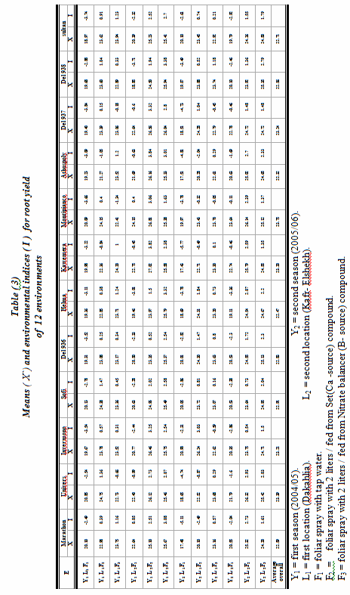

Table ( 4 )
combined analysis of variance for root yield of 12 varieties
over 12 environments
Source of variation | d.f | M.S
Environments (E) | 11 | 232.659**(MSL)
Reps / Environments | 36 | 0.772 (MSB)
Genotypes (G) | 11 | 8.815** (MSG)
ExG | 121 | 3.682** (MSGL)
Environments + Envi. x Genot. | 132 | 22.763** -
Environments (Linear) | 1 | 639.834** -
E x G (Linear response) | 11 | 206.733** -
Dev. from linear response | 120 | 0.757 -
Pooled error | 396 | 0.632 (MSe)
Linear proportion of variance (%) |  | 99.63
Indicate significant at 1% level of probability.**

Table ( 5 )
Mean root yield ,phenotypic (b_{i} , S² _{di} ) and (α , λ) stability parameter for sugar beet varieties over 12 environments
Varieties | -x | b_{i} | $$±$$ | S.E | S²_{di} | α_{i} | λ_{i} | Dev.MS  /Mse/r
1. Marathon | 22.59 | 0.657* | $$±$$ | 0.169 | 0.056 | 0.032 | 8.545 | 0.338
2. Univers | 23.39 | 1.302* | $$±$$ | 0.129 | 0.472* | 0.003 | 3.955 | 0.996
3. Invermono | 23.21 | -0.612* | $$±$$ | 0.896 | 0.071 | -0.067 | 9.350 | 0.362
4. Sofi | 22.91 | 2.398* | $$±$$ | 0.502 | 1.345* | -0.125 | 2.802 | 2.378
5. Del 936 | 22.83 | 1.069 | $$±$$ | 0.225 | 0.079 | -0.072 | 3.204 | 1.008
6. Helma | 22.47 | -0.036* | $$±$$ | 0.985 | -0.097 | 0.088 | 5.794 | 0.096
7.Kawamera | 23.20 | 0.873 | $$±$$ | 0.119 | 1.219* | 0.096 | 6.839 | 2.178
8. Montipianco | 23.75 | 1.541* | $$±$$ | 0.407 | 2.572* | -0.152 | 7.018 | 4.316
9. Athospory | 22.32 | 0.272* | $$±$$ | 0.790 | 0.018 | 0.130 | 7.026 | 0.278
10. Del 937 | 23.24 | 2.611* | $$±$$ | 0.363 | 0.543* | 0.024 | 3.954 | 1.109
11. Del 938 | 22.56 | 1.012 | $$±$$ | 0.016 | 0.538* | 0.056 | 4.502 | 1.100
12. Sultan | 22.71 | 0.002 | $$±$$ | 0.582 | -0.029 | -0.013 | 3.091 | 0.204
Average Overall | 22.93

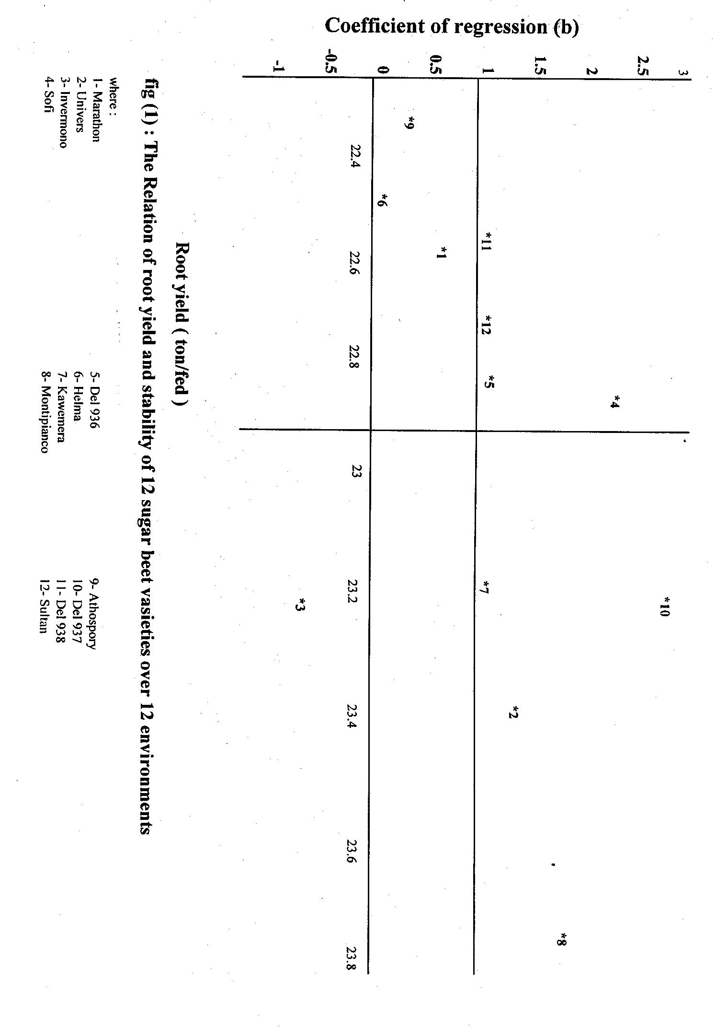

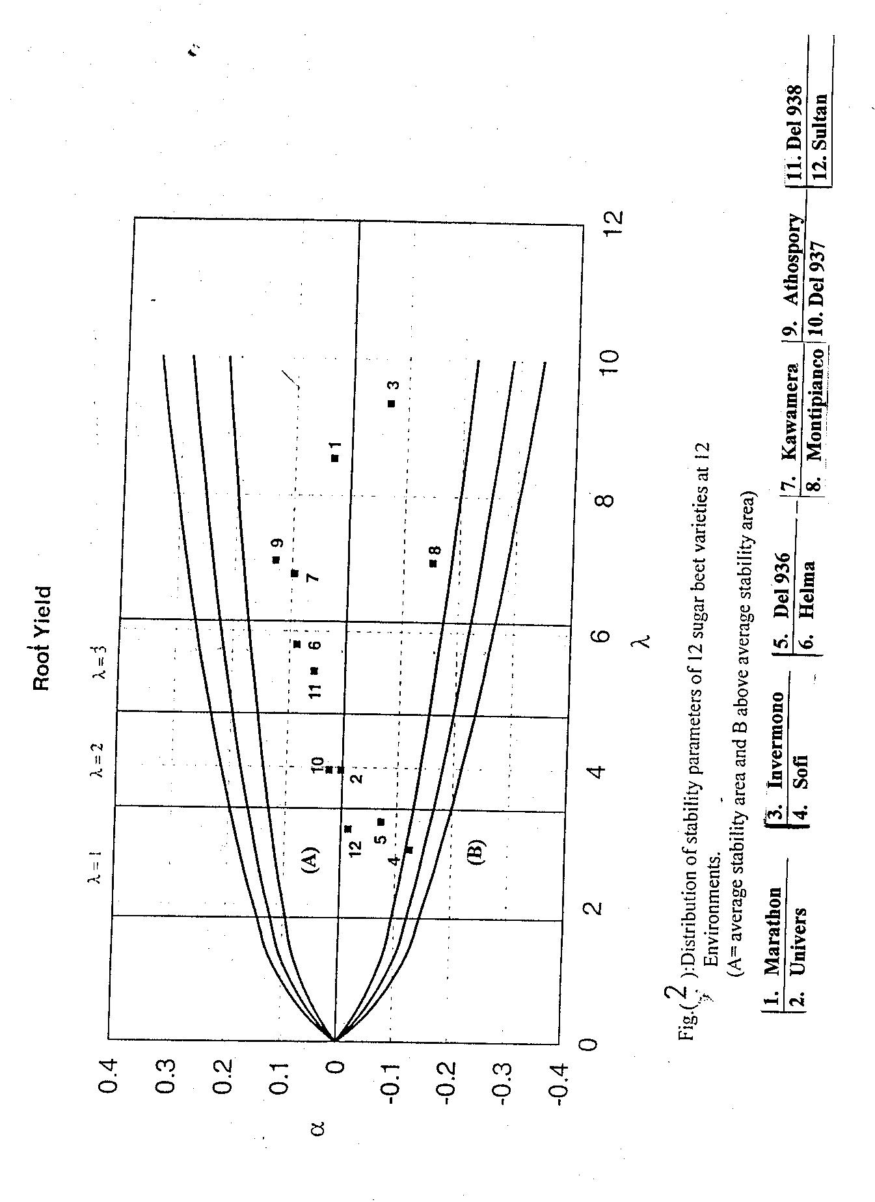
REFERENCE :
Allard,R.W. and A.D.Bradshaw (1964). Implication of genotype environmental interactions in applied plant breeding.Crop Sci.4:503-507.
Bartlette,M. (1937). The statistical conception of mental factors, British Journal of Psychology, 28,97-104.
Becker,H.C.; Geiger,H.H. and K.Morgenstern (1982). Performance and phenotypic stability of different hybrid typesin winterrye.Crop Sci. , 22: 340-344.
Chloupek,-O and P. Hrstkova (2005). Adaptation of crops to environment. TAG Theoretical and Applied Genetics.; 111(7): 1316-1321 .
Denis, J.B; Piepho, H.P and F.A. Eeuwijk (1997). Modelling expectation and variance for genotype by environment data. Heredity-. 1997; 79(2): 162-171
Eberhart ,S.A. and W.A. Russel (1966). Stability parameters for comparing varieties. Crop Sci. 6: 36-40.
El-Hinnawy, H.H; Mahmoud, E.A; Ramadan, B.S.H and Farag, M.A. (2003) Phenotypic stability for some sugar beet genotypes. Proceedings of the international conference on Arab region and Africa in the world sugar context' , Aswan, Egypt, 9-12-March-2003.; P.4 .
Ghandorah,M.O and Y.A.Refay (1994) Effect of sowing date and cultivar on sugar beet (Beta vulgaris L.) productionin the centralregion of Saudi Arabia ,Arab Gulf Journal of Scientific Research.,12(3):465-478.
Gyllenspetz, U. (1988). Genotype environment interaction and stability of diploid triploid sugar beet (Beta vulgaris L.) varieties. 155+ 36 pp.; 8 pp. of ref.
Hoffmann,-C-M and B. Marlander (2005) Composition of harmful nitrogen in sugar beet (Beta vulgaris L.) α- amino acids, betaine, nitrate - as affected by genotype and environment. European Journal of Agronomy. 22(3): 255-265.
Jackson,M.L.(1958). Soil chemical analysis.2nd ed Prentice Mall cp.,Englewood Cliffs,New York.80.
Korneeva,M.A.;Nikolaenko,N.V.and L.I.Lishchitovich (1987) Ecological and genetic evaluation of yield in promising breeding forms of sugar beet Sel" Skohhozyaiistvennaya Biologiya No.9 , 18-23; 12 ref.
Liovic,-I; Kristek,-A . (2000) Stability of agronomic traits in sugar beet hybrids . Rostlinna-Vyroba. 2000; 46(4): 169-175.
Piepho,-H-P (1995). Implication of correlations among some common stability statistics - a Monte Carlo simulation. Theoretical and Applied Genetics. 90(3/4): 457-461.
Sanbuichi,T.; Matsuzaki,Y.; Yoshida,T.; Tsukishima,N.; Kurosawa,K.; Tudsumi,T.; Mukalyama,K.; Ara,K. and K.Sako (1981). Varietal differences in response to cultivation and environmental conditions in sugar beet. Madras Agricultural J. 61: 129 – 130 [ C. F. Plant Breed. Absts., Vol. 53 (7) : 5682 ].
Tai , G.C.C. ( 1971). Genotypic stability and its application to Potato Regional Trials. Crop Sci. 11: 184-190.
Tripathi, B. K. and H. M. Srivastava (1978) Yield and stability of some sugar beet(Beta vulgaris l.)varieties.Indian J.sugar beet Tech.,1(1):8-12.

