EFFECT OF WEED COMPETITION AND ITS CONTROL METHODS ON GROWTH, RESIDUES AND YIELD OF CABBAGE (BRASSICA OLERACEA VAR CAPITATA)
Fadlallah, A. M. 1 Hassanein, A. M. A. 1 Hatem, M. K. 2
1- Central Laboratory for Weed Research, Giza, Egypt.
2- Horticulture Research Institute, Giza, Egypt.
ABSTRACT
Two studies were conducted at Horticulture Research Station, El-Kanater El-Khiria, Kalubia governorate. Firstly, two field experiments were carried out in 2008/09 and 2009/10 winter seasons to evaluate the efficacy of some herbicidal treatments on weed control and yield productivity of cabbage plants. Each experiment including six treatments namely Roundup, Amex, Amex plus hand hoeing one, Fusilade super and hand hoeing as well as the unweeded treatment. Secondly, two field experiments were carried out in 2009/10 and 2010/11 winter seasons to determine the period required for weed free maintenance after cabbage transplanted to produce the maximum yield and/or the weed competition period which can be allowed without reducing the yield; beside the bases of the cabbage yield due to weed competition. This study contain ten treatments of weed removal and weed competition which four of them weed free period at 3, 6, 9 and 12 weeks and weed free treatment for all season from cabbage transplants and four treatments of weed competition at 3, 6, 9 and 12 weeks from cabbage transplants and weed competition treatment for all season. The main results revealed that Roundup 48 % herbicide applied at 1 l/fed. gave the highest reduction percentage of the dry weight of the total annual weeds but Fusilade super 12.5 % at 1 l/fed. on reducing the dry weight of annual grassy weeds only. While Amex 48 % at 2.5 l/fed. plus one hand hoeing gave the following significant reduction on both categories weeds. These results reflected on increasing the yield and its components. Also, there was no residues of Amex 48% at 2.5 l/ fed. as soil herbicide and Fusilade super 12.5 % at 1 l/fed. as post emergence herbicide on the tested cabbage leaves.
On the other hand, nine weeks required for kept weed free to obtain the maximum yield and three weeks of weeds competition without reducing cabbage yield.
Key words: Herbicides – hand hoeing – residues- critical period.
INTRODUCTION
Most of the vegetables crops are considered to be extremely poor competitor against weeds in field conditions. Ibrahim et al. (1989) reported that cabbage yield reduction in unweeded check compared with hand hoeing at four times was estimated by 59.7 and 65.8% in two seasons, respectively. Arora and Gopal (2004) and Dixit et al. (2005) indicated that pendimethalin at 0.50 kg a.i./ha. was highly effective for weed control in cabbage and with one manual weeding/hoeing recorded the highest head weight of 30.18 t/ha.
and gave the highest benefit /cost ratio (2.24 LE). Semidey et al. (1999), Bracy and Parish (2003), Sanjeev et al. (2003) and Dillard et al. (2004) stated that the oxyfluorfen at 0.16 kg a.i./ha. pendimethalin at 0.75 kg a.i./ha. and metribuzin at 0.70 kg a.i./ha. Significa
ntly reduced the weeds population and at dry weight accumulation at 45 days after transplanting cabbage and increased the cabbage yield above that of the untreated control. Dhiman et al. (2005) found that pendimethalin at 1.0 kg ha-1 resulted in the highest number of total heads per plot (26.67), marketable heads per plot (18.83), average head weight (0.632 kg), marketable yield (141.97 q/ha), the maximum returns (Rs. 26 517)/ hectare. Qasem and Hill (2003) cited that weed/crop competition on cabbage resulting in reduced its shooting dry weight compared with the control (no competition). On the other hand, the critical period has been defined as the period which weeds must be controlled to prevent yield losses (Zimdahl 1988). Whilst, Weaver et al., (1992) reported that the critical period represents the time interval between the maximum weed infested period before weeds begin to interfere with crop growth and the minimum weed-free period in order to prevent yield loss.
Therefore, the present work was designed to find out the success herbicidal treatments; and to recognize the suitable time of weeds removing in cabbage plants and using these information's to choose the effective integrated weed control.
MATERIALS AND METHODS
The present work consisted of four field experiments were carried out at the Horticulture Research Station, El-Kanater El-Khiria, Kalubia governorate throughout 2008/09 to 2010/11 winter seasons. In the 1st two experiments were conducted in 2008/09 and 2009/10 winter seasons to evaluate six weed control treatments on controlling the annual grassy and broad leaf weeds and reflected that on cabbage yield and its components as follows:
The first experiment included six weed control treatments as follows:
1- Unweeded check.
2- Hand hoeing at two times with 15 days intervals, and beginning at 18 days of transplanting.
3- Butralin (4-(1,1-dimethylethyl)-N-(1-methylpropyl) -2,6-dinitrobenzenamine) known commercially as Amex 48 % EC, was applied at rate 2.5 liter/fed. as pre-transplanting.
4- Butralin (as Amex 48 % EC, was applied at rate 2.5 liter/fed. as pre-transplanting) + one hand hoeing was done after one month from transplanting.
5- Fluazifop-butyl (butyl (R)-2-[4-[[5-(trifluoromethyl)-2-pyridinyl] oxy] phenoxy] propanoate) known commercially as Fusilade super 12.5 % EC was applied at rate of 1 liter/fed. after one month from transplanting.
6- Glyphosate (N-(phosphonomethyl) glycine), known commercially as Roundup 48 % WSC was applied at rate of 1 liter/fed. at one month from transplanting and after covering the plants of plastic bags.
In the 2nd two experiments were conducted in 2009/10 and 2010/11 winter seasons were designed in ten varying of weed competitions and weed-free to determine the critical period and losses of cabbage yields due to weed competition as follows:
1- Weed free for the whole season.
2- Weed free for 3 weeks from transplanting only.
3- Weed free for 6weeks from transplanting only.
4- Weed free for 9 weeks from transplanting only.
5- Weed free for 12 weeks from transplanting only.
6- Weed competition for the whole season.
7- Weed competition for 3 weeks from transplanting after them weed free until the end of season.
8- Weed competition for 6 weeks from transplanting after them weed free until the end of season.
9- Weed competition for 9 weeks from transplanting after them weed free until the end of season.
10- Weed competition for 12 weeks from transplanting after them weed free until the end of season.
All herbicidal treatments were sprayed with knapsack sprayer CP3 with 200 liter water/fed. The agriculture practices i.e., fertilization; irrigations; pest and diseases control were managed in accordance with local recommendations. The soil texture of the experiments sites was clay and 8.01 PH.
The treatments were arranged in randomized complete block design with four replicates. The plot area was 10.5 m2 (3.5 m length x 3 m width). The seedlings were transplanted in 15/9/2008 and 13/9/2009 in the 1st two experiments, respectively and both harvested in the second week of January. While, in the 2nd two experiments, the seedlings were transplanted in 22/9/2010 and 20/9/2011 and both harvested at the third weeks of January.
In these four field experiments, in the two studies, the following data were recorded as follows:
A- Weed characters:-
A random sample was taken from one m2 from each plot after one month from the last treatment in the first two experiments and the end of the second other two experiments. The sample was classified to grassy and broad leaves weeds and dried in oven 70 C until constant weights then the dried weeds were weighted.
B- Growth characters and cabbage yield:-
1- Stem diameter (cm).
2- Weight head (kg.).
3- Diameter of head (cm).
4- Length of head (cm).
5- Number of leaves/plant.
6- Number of cabbage/fed.
7- Stem length (cm).
8- No. of head/fed.
9- Yield kg/fed. in the two field experiments of the second study only (head weight "kg/fed" x No. of head).
C- Herbicide residues:
The herbicides residues for Amex (butralin) and Fusilade super (fluzaifop-p-butyl) in cabbage leaves were analyzed by using the gas liquid Chromatography according to Nguyen et. al. (2008).
D – Determination economic for weed control in cabbage.
Economic evaluation due to weed control treatments was calculated according to Heady and Dillon (1961) as follows:
Gross income = No. of heads x price of head.
Gross margin = gross income – total cost.
Benefit / cost ratio = gross income / total cost.
Noticed that: C and D data belonging the first two experiments only.
E- Estimation critical weed control period:
Data of each season were statistically analyzed according to the procedures outlined by (Gomez and Gomez 1984) and the means were compared by least significant differences (L.S.D. at 5 %). The relative and actual yield were subjected to analysis of variance using Regression Curve Estimation Functions to analysis of Statistical producers for social sciences (SPSS 12.0 for windows), to evaluate the effect of the length of the weed –free period and increasing duration of weed interference on relative lentil yields (Evans et al., 2003; Knezevic et al., 2002 and Norsworthy and Oliveira, 2004). Relative yield of each treatment was calculated in percent of the corresponding weed-free yield. Three response curve models namely, linear, quadratic and logistic were fitted to study the relationships between yield/fed and duration of weed-free or weed-competition period during first and second seasons. First and second model are linear and quadratic according to (Neter et al., 1990). A three model logistic equation proposed by (Hall et al., 1992) and modified by (Knezevic et al., 2003), was used to describe the relation between increasing duration weed interference on relative yield to determine the onset of critical period of weed control. Also, logistic regression model is presented in (Agresti 1996). The dependent or response and independent or predictor variables in this model area categorical, continuous or a mix of continuous and categorical (Tabachick and Fidell 1996) use the term polychotomous. The independent or predictor variables in logistic regression can take any form. That is, logistic regression makes no assumption about the distribution of the independent variables. They do not have to be normaly distributed, linearly related or of equal variance within each group.
Statistical techniques:
* Linear model is estimated using the formula:
Y = a + b x
Where: Y = is the yield/fed. in ton.
a : is the Y intercept.
b : is the linear coefficient of regression.
x : is the duration of applied weed-free or weed.
Competition period.
* Quadratic polynomial model is computed using the formula:
Y = a + bx + cx2
Where: Y = is the yield/fed. in ton.
a : is the Y intercept.
b : is the linear coefficient of regression.
c : is the quadratic coefficient of regression.
X: is the duration of applied weed-free or weed-competition period.
* Logistic regression equation is computed using the formula:
Y = 1/(1/u + (b0*(b1* *t)))
Or = ln (1/y – 1/u) Or Y=ln (bo) + (ln (b1)*t)
Where: U = is the upper bounder value of y. The value must be a positive no/greater than the largest dependent variable value.
b0 = is the constant (a).
b1 = is the regression coefficient.
T = is the independent variable, x.
Data were analysis statistical by Central Laboratory for design and statistical analysis Research, Agriculture Research Center, Giza, Egypt.
RESLTUS AND DISCUSSION
The most predominant weeds flora in the four field trials during 2008/09, 2009/10 and 2010/11 winter seasons were Amaranthus viridis, portulaca oleracea and Gynandropsis gynandra as annual broad leaf weeds and Setaria viridis and Echinochloa colonum as annual grassy weeds.
I. In the first study (the effect of weed control treatments on weeds and cabbage yield and its components).
From table (1), the infestation rate of the annual grassy and broad leaf weeds were 0.41 & 1.27 ton dry weight and 0.48 & 1.72 ton dry weight/fed. in 2008/09 and 2009/10 winter seasons, respectively.
It was noticed that the herbicidal treatments used and hand hoeing twice gave significant effect on controlling the above mentioned weeds in both seasons.
Round up at 1 l/fed, Amex at 2.5 l/fed. plus hand hoeing once and Amex at 2.5 l/fed. gave the reduction percentage on the dry weight of the annual grassy and broad leaf weeds by 93.2 & 94.3 %; 89.1 & 94.3 % and 88.3 & 93.5 %, followed by hand hoeing twice by 80.1 & 85.4, compared to unweeded check respectively, in the first season.
Table (1): Effect of weed control treatments on dry weight of grassy, broad leaf and total weeds g/m2 during 2008/2009 and 2009/2010 seasons
Seasons |  |  |  | 2008 |  |  |  |  |  | 2009
Characters |  |  |  |  |  |  | Dry weight of weeds (g/m2)
Treatments | Grasses | % | Broad leaf |  | % | Total |  | Grasses | % |  | Broad leaf | % | Total
Amex at 2.5 l/fed. | 11.5c | 88.3 | 19.8d |  | 93.5 | 31.3d |  | 12.6c | 88.9 |  | 19.4bc | 95.3 | 37.0cd
Amex and 1 hoeing | 10.7c | 89.1 | 17.3e |  | 94.3 | 28.0e |  | 11.7c | 89.7 |  | 16.5bc | 96.0 | 28.2cd
Roundup at 1l/fed. | 6.7d | 93.2 | 17.3e |  | 94.3 | 24.0f |  | 8.2e | 92.8 |  | 13.9c | 96.6 | 22.1d
Fusilade at 1l/fed. | 6.7d | 93.2 | 294.9b |  | 2.6 | 301.6b |  | 9.5d | 91.7 |  | 406.5a | 0.5 | 416.0b
Hand hoeing 2 times | 19.5b | 80.1 | 44.3c |  | 85.4 | 63.8c |  | 21.5b | 81.1 |  | 59.2b | 85.5 | 80.7c
Control | 98.1a | - | 302.7a |  | - | 400.8a |  | 114.0a | - |  | 408.5a | - | 522.5a

While the previous respective herbicides gave the reduction percentage on the dry weight of the both two weeds categories by 92.8 & 96.6 %; 89.7 & 96.0 % and 88.9 & 95.3 %; followed by hand hoeing twice by 81.1 & 85.5 %, in the second season. On the other hand, Fusilade super at 1 l/fed. as a graminicide gave significant result on reducing the dry weight of grassy weeds only by 93.2 % and 91.7 % in both seasons, respectively.
In table (2), the above results on controlling weeds reflected on increasing the cabbage yield and its components with significant effect on both seasons. Increasing percentages of the number of cabbage head/fed. were obtained by the following treatments in a descending order:
Round up at 1 l/fed by (29.3 %), Amex at 2.5 l/fed. plus hand hoeing once (25.5 %), Amex at 2.5 l/fed. (14.6 %) and hand hoeing twice (11.2 %) compared to unweeded control, in the first season. Also, the same previous respective treatments increased the number of cabbage head/fed by 26.8, 24.5; 14.5 and 11.3 %, compared to unweeded control in the second season.
Table (2): Effect of weed control treatments on growth characters at harvest during 2008/2009 and 2009/2010
Characteristics |  |  |  |  | 2008 season
 | Stem diameter (cm) | Weight of head (kg) | Length of head (cm) | diameter head (cm) | No. of leaves/ plant | No. of cabbage/ plant | Stem length (cm) | No. of head/ fed. | % increase in No. of head
Treatment
Amex at 2.5 l/fed. | 4.7c | 8.1b | 30.7c | 30.0b | 5.3cd | 32.0b | 13.0b | 8200 | 29.3
Amex and 1 hoeing | 5.1b | 8.6a | 32.3b | 36.0a | 5.0d | 34.7a | 12.0bc | 9400 | 25.5
Roundup at 1l/fed. | 5.6a | 9.0a | 34.3a | 37.7a | 4.3d | 37.0a | 11.0c | 9900 | 14.6
Fusilade at 1l/fed. | 4.1d | 6.8c | 29.0d | 28.0cd | 6.7b | 31.7b | 12.3bc | 8000 | 12.5
Hoeing 2 times | 4.0d | 6.9c | 30.0cd | 29.0bc | 6.3bc | 30.0b | 13.7b | 7900 | 11.4
Control | 3.9d | 5.9d | 28.7d | 26.3d | 11.0a | 23.7c | 16.7a | 7000 | -
2009 season
Amex at 2.5 l/fed. | 5.0b | 8.2b | 29.7b | 28.7b | 5.3cd | 33.0b | 13.0b | 8300 | 26.8
Amex and 1 hoeing | 5.2b | 8.7a | 33.3a | 35.3a | 6.3bc | 35.0a | 12.3b | 9400 | 24.5
Roundup at 1l/fed. | 5.8a | 9.1a | 33.7a | 37.0a | 4.3d | 36.0a | 10.7c | 9700 | 14.5
Fusilade at 1l/fed. | 4.3c | 7.5c | 31.0b | 29.3b | 7.3b | 31.3bc | 13.3b | 8100 | 12.3
Hoeing 2 times | 4.2c | 7.1c | 30.0b | 30.3b | 7.0bc | 30.0c | 16.0a | 8000 | 11.3
Control | 4.1c | 6.3d | 29.3b | 28.7b | 12.3a | 24.0d | 17.0a | 7100 | -

On the other hand, Fusillade super at 1 l/fed. gave the lowest significant increasing the number of cabbage head/fed by 12.5 % and 12.3 %, in both seasons, respectively.
Actually, the same trend of the above findings and the same arrangement of the treatments were observed with significant effect on cabbage components i.e. stem diameter, weight of head, length of head, diameter of head, No. of leaves, No. of cabbage and stem length. That was true in both seasons. However, Fusilade super at 1 l/fed. decreased with significant effect in this characters in both seasons. That may be due to fail of controlling the broad leaf weeds which it the dominant weeds in this study.
Residues analysis.
From figs (1-4) and (Table 3) the gas liquid Chromatography was not recorded signal to two herbicidal used (not detected). These two herbicides (Butralin, Fluazifop-p-butyl) degraded into the cabbage plants and the GLC couldn't read any values.
Table (3): Resides for butralin and fluazifop- p- butyl in cabbage leaves.
Sample No. | Residual (ppm)
Butralin | *Not detected (ND)
Fluazifop-p-butyl | Not detected (ND)

* Not detected: Below detection limit 0.01 ppm for Butralin and 0.02 ppm for Fluazifop-p-butyl

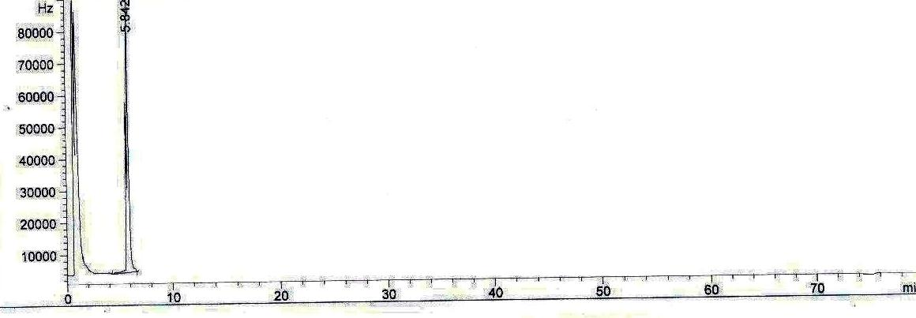
Response

Rational times
Fig (1): Standard of Butralin.

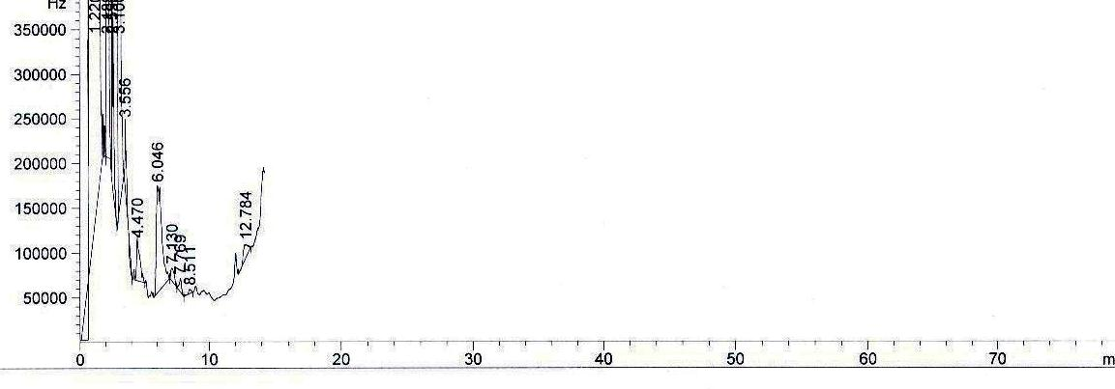

Response

Rational times
Fig (2): Residual of Butralin in cabbage leaves.

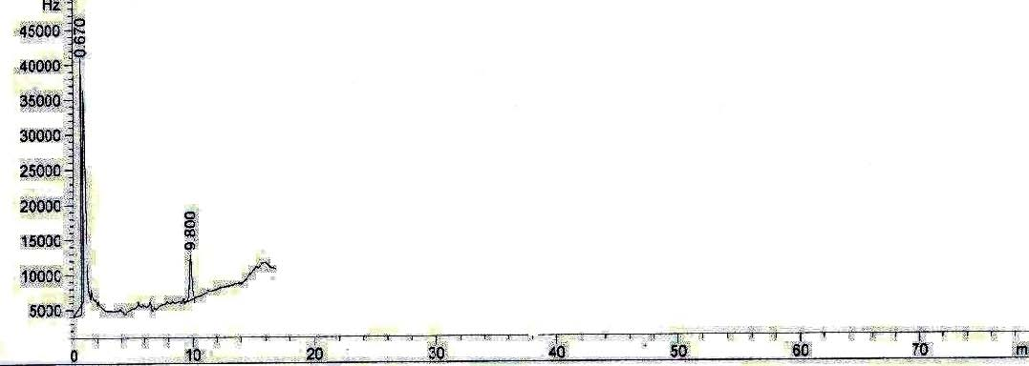

Response

Fig (3): Standard of Fluazifop-p-butyl.

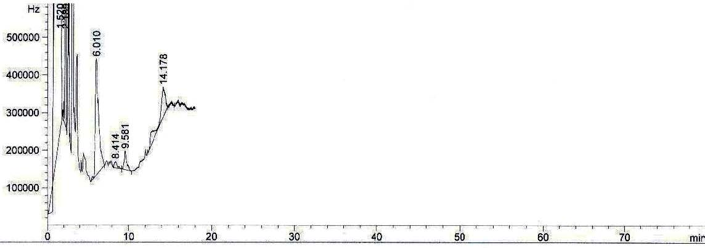

Response

Fig (4): Residual of Fluazifop-p-butyl in cabbage leaves.

Determination economic for weed control in cabbage.
Data in table (4) show that the total cost of the weeded check was 1920 and 2050 LE in 2008/09 and 2009/10 seasons, respectively, which as considered the fixed cost ((land preparation, transplantation fertilization irrigation, insect control, harvesting and transportation) addition; to the cost of the treatments on the others.
In both seasons, Round up at 1.0 l/fed. gave the highest values of Gross income, net benefit and the percentage of benefit/cost by 9900 & 9700 LE; 7890 & 7600 LE and 4. 93 & 4.62, respectively.
Amex at 2.5 l/fed. plus hand hoeing once was the following treatment which increasing the respective previous economic values by 8460 & 8460 LE; 6165 & 6060 LE and 3.69 & 3.52.
Whilst, the rest treatments i.e., Amex at 1.0 l/fed, Fusilade super at 1.0 L/fed. and hand hoeing twice were still superior of the previous economic value compared to unweed chick.
Table (4): Determination economic for weed control in cabbage.
Characteristics Treatment | Total cost L.E. | Gross income L.E. | Net benefit L.E. | B/C
2008 season
Amex at 2.5 l/fed. | 2145 | 6150 | 4005 | 2.85
Amex and 1 hoeing | 2295 | 8460 | 6165 | 3.69
Roundup at 1l/fed. | 2010 | 9900 | 7890 | 4.93
Fusilade at 1l/fed. | 2500 | 4740 | 2240 | 1.90
Hoeing 2 times | 2150 | 5600 | 3450 | 2.60
Control | 1920 | 3500 | 1580 | 1.82
2009 season
Amex at 2.5 l/fed. | 2350 | 6225 | 3875 | 2.65
Amex and 1 hoeing | 2400 | 8460 | 6060 | 3.52
Roundup at 1l/fed. | 2100 | 9700 | 7600 | 4.62
Fusilade at 1l/fed. | 2700 | 4800 | 2100 | 1.80
Hoeing 2 times | 2200 | 5670 | 3470 | 2.58
Control | 2050 | 3550 | 1500 | 1.73

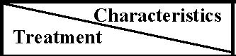
The second study (the effect of weed competition treatments on weeds and cabbage yield and yield components):
It is notable from the data in table (5) that the infestation rate for the whole season recorded 0.50 ton and 1.43 ton dry weight/fed for grasses and broad leaf weeds, respectively, in both seasons approximately. Furthermore, increasing intervals of weeds removal (weed free) resulted in a gradual decrease in the weight of the remaining weeds until the twelve week which reaches in nearly to the weed free for the whole season. On contrary, the weight of the remaining weeds after the different weeds competition intervals was approximately equally. That may be due to density of the presented weeds was low to medium in both seasons.
Table (5): Effect of weed competition treatments on dry weight of grassy, broad leaf and total weeds g./m2 during 2009/2010 and 2010/2011.
season |  |  | 2010 |  |  |  | 2011
Characteristics |  |  |  |  | Dry weight of weeds (g/m2)
Treatments | Grassy | Broad leaf |  | Total |  | Grassy |  | Broad leaf | Total
Weed free 3 weeks | 95.12b | 278.50b |  | 373.62b |  | 90.70b |  | 307.00b | 397.7b
Weed free 6 weeks | 29.78c | 122.20c |  | 151.98c |  | 38.50c |  | 200.00c | 238.5c
Weed free 9 weeks | 10.72d | 61.23d |  | 71.95d |  | 11.90d |  | 81.27d | 93.17d
Weed free 12 weeks | 4.65fg | 13.51g |  | 18.16g |  | 5.93f |  | 17.57g | 23.47g
weed free all season | 2.57g | 8.70h |  | 11.27h |  | 3.13g |  | 14.00h | 17.13h
Weed competition 3 weeks | 6.65ef | 18.55f |  | 25.20f |  | 8.26e |  | 13.23fg | 27.50f
Weed competition 6 weeks | 7.21ef | 19.67ef |  | 26.88ef |  | 9.90de |  | 19.97ef | 29.83ef
Weed competition 9 weeks | 7.41ef | 20.56ef |  | 27.97ef |  | 10.0de |  | 20.33ef | 30.33ef
Weed competition 12 weeks | 8.58de | 22.87e |  | 31.45e |  | 11.07d |  | 21.40e | 32.43e
Weed competition all season | 118.40a | 340.10a |  | 458.50a |  | 116.10a |  | 344.50a | 460.6a

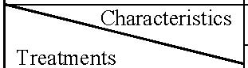
In table (6) revealed that all studied treatments exceeded significantly the weed competition for the whole season in the head cabbage yield/fed. and its components in both seasons except in the case of weed competition for twelve weeks in first season and weed free for three weeks in second season.
In both seasons, the optimum head cabbages weight/fed. was obtained with weed free for the whole season by 86.6 ton and 84.5 ton/fed, respectively. Whilst, weed free for 12, 9 and 6 weeks and weed competition for 3 weeks gave 84.7, 81.2, 78.0 and 83.6 ton/fed., respectively, in first season and 82.8, 81.0, 79.3 and 82.5 ton/fed., respectively, in second season.
Furthermore, the significant increasing of the cabbage components i.e., stem diameter, weight of head, length of head, diameter of head, No. of leaves, No. of cabbage and stem length reflected on its yield as maintained above.
Table (6): Effect of weed competition treatments on growth characters at harvest during 2009/20010 and 2010/2011
Treatments | Stem diameter (cm) | Weight of head (kg) | Diameter of head (cm) | Length of head (cm) | No. of Leaves /plant | No. of cabbage /plant | Stem length (cm) | No. of head/ fed. | Yield/ fed. kg
1st season
Weed free for 3 weeks | 4.10e | 6.8d | 27.70e | 31.70e | 9.00e | 31.60f | 14.10e | 8000de | 54130e
Weed free for 6 weeks | 4.50d | 8.7c | 32.10c | 32.80c | 7.00g | 33.50d | 13.10f | 9000c | 77980d
Weed free for 9 weeks | 4.80 bc | 8.8bc | 36.80b | 33.80b | 5.30h | 35.00c | 12.00g | 9233bc | 81230c
Weed free for 12 weeks | 5.00ab | 8.9ab | 37.30ab | 34.00b | 4.60i | 36.60b | 11.30h | 9483ab | 84720ab
weed free for all season | 5.20a | 9.0a | 38.00a | 34.20a | 4.10j | 37.30a | 10.90h | 9587a | 86580a
Weed competition for 3 weeks | 4.60cd | 8.9ab | 31.50c | 33.00c | 8.40f | 32.80e | 14.00e | 9363ab | 83630bc
Weed competition for 6 weeks | 4.40d | 6.4e | 30.00d | 32.80c | 9.70d | 31.10g | 14.80d | 8213d | 52940e
Weed competition for 9 weeks | 4.00e | 6.2e | 27.80e | 32.20d | 10.50c | 28.30h | 15.70c | 7947de | 49270f
Weed competition for 12 weeks | 3.70f | 5.9f | 27.00f | 31.00f | 11.30b | 25.40i | 16.40b | 7783ef | 45920g
Weed competition for all season | 3.10g | 5.8f | 25.90g | 28.90g | 12.00a | 24.70j | 17.00a | 7597f | 43810g
2nd season
Weed free for 3 weeks | 4.30d | 8.0d | 32.1f | 31.80e | 9.50c | 30.00g | 18.10c | 8280e | 66520e
Weed free for 6 weeks | 4.70c | 8.9c | 34.7d | 32.10e | 8.60de | 31.00f | 16.10d | 8943c | 79300d
Weed free for 9 weeks | 4.90bc | 9.0b | 38.6c | 33.50d | 7.10f | 34.00d | 14.70e | 8967c | 81000c
Weed free for 12 weeks | 5.10b | 9.1b | 41.0b | 35.90c | 5.20h | 36.00b | 12.70g | 9073b | 82750b
weed free for all season | 5.40a | 9.2a | 42.9a | 38.10a | 4.10i | 38.60a | 11.10h | 9160a | 84490a
Weed competition for 3 weeks | 5.10b | 9.1b | 41.0b | 36.90b | 6.10g | 35.20c | 13.40e | 9063b | 82480b
Weed competition for 6 weeks | 4.70c | 8.0d | 38.7c | 33.00d | 8.30e | 33.40e | 14.80e | 8370d | 67240e
Weed competition for 9 weeks | 4.70c | 7.9e | 33.2e | 31.60e | 10.40b | 31.60f | 16.20d | 8253e | 65200f
Weed competition for 12 weeks | 4.10d | 7.8f | 31.0g | 30.10f | 8.90d | 30.20g | 18.30b | 8197f | 63930g
Weed competition for all season | 3.70e | 7.7g | 28.0h | 25.80g | 12.10a | 28.10h | 20.00a | 8123g | 62550h

Data in table (7) show that the weed free for 12 weeks from cabbage transplanting gave the lowest values of the weeds dry weight by 0.08 and 0.1 t/fed. and reflected that to gave the lowest reduction percentage of the cabbage yield by 2.15 and 2.06% in both seasons, respectively, with the weed free for whole season which gave weeds dry weight by 0.05 and 0.07 t/fed. On the other hand, the weed competition for 3 weeks of cabbage transplanting was approximately gave same previous results. This treatment gave weed dry weight by 0.11and 0.12 t/fed. and reduce percentage of the yield by 3.41 and 2.38% in both seasons, respectively.
Table (7): Reduction percentage in cabbage yield due to weed competition in 2009 and 2010 seasons.
Treatments |  |  | 2009 |  |  | 2010
 | Dry weight of weeds/fed. | Yield t./fed. |  | Reduction % | Dry weight of weeds/fed. |  | Yield t./fed. | Reduction %
Weed free for 3 weeks | 1.57 | 54.1 |  | 37.51 | 1.67 |  | 56.52 | 33.10
Weed free for 6 weeks | 0.64 | 77.98 |  | 9.93 | 1.00 |  | 79.3 | 6.14
Weed free for 9 weeks | 0.30 | 81.23 |  | 6.18 | 0.39 |  | 81.00 | 4.13
Weed free for 12 weeks | 0.08 | 84.72 |  | 2.15 | 0.10 |  | 82.75 | 2.06
weed free for all season | 0.05 | 86.58 |  | - | 0.07 |  | 84.49 | -
Weed competition for 3 weeks | 0.11 | 83.63 |  | 3.41 | 0.12 |  | 82.48 | 2.38
Weed competition for 6 weeks | 0.12 | 52.94 |  | 38.85 | 0.13 |  | 67.24 | 20.42
Weed competition for 9 weeks | 0.13 | 49.27 |  | 43.09 | 0.13 |  | 65.20 | 22.83
Weed competition for 12 weeks | 0.13 | 45.92 |  | 46.96 | 0.14 |  | 63.93 | 24.33
Weed competition for all season | 1.93 | 43.18 |  | 50.12 | 1.93 |  | 62.55 | 25.96

Determination critical period of weed control as affected by weed treatments.
Obtaining 100 percentage yield for cabbage crop for free season from weeds (15 weeks) is high costing. So, obtaining 90% yield is accepted by determining critical period of weed control (CPWC) according to the recommended allowed losing yield value (10%). To achieve this target, the relation among yield and each of weed –free and weed competition was studied using some type of curves namely: Linear, logistic and quadratic models. Three bases were considered to compare among the three models i.e. coefficient of determination (R2), standard error of estimate (SE) and the significance of the model. The significant model which had highest R2 and lowest SE was the best model fitted to the yield data.
Table (8) clear the value of coefficient of determination (R2), standard error of estimate (SE) and calculated F value of the tested models in 2009 and 2010 seasons. Results clearly present that the highest value of coefficient of determination (R2), was in favour of Quadratic model for weed-free and weed competition in 2010 and 2011 seasons

Table (8): Parameters of three models that were studied on the effect of weed control treatments on cabbage yield in 2010 and 2011 seasons.
Season | Treatments | Methods | R2 | S. E. | Sig. | Prediction equation | CPWC/ week allowed losing yield (10%)
2010 season | Weed-free | Linear | 0.724 | 6.714 | 0.00 | Y=98.42 + 2.38x
 |  | Logistic | 0.690 | 4.104 | 0.00 | Y= ln (9.7) + ln (1.035)x
 |  | Quadratic | 0.917 | 3.820 | 0.00 | Y= 76.6 + 3.85x 0.35x2 | 6.3
 | Weed competition | Linear | 0.698 | 8.850 | 0.00 | Y= 28.71 + 2.96x
 |  | Logistic | 0.760 | 5.126 | 0.00 | Y=ln(2.89)+ln(0.953)x
 |  | Quadratic | 0.923 | 4.660 | 0.00 | Y=58.45+5.54x0.472x2 | 3.8
2011 season | Weed-free | Linear | 0.749 | 3.400 | 0.00 | Y=90.54+1.31x
 |  | Logistic | 0.729 | 3.048 | 0.00 | Y=ln(1.09)+ln(1.017)x
 |  | Quadratic | 0.916 | 2.010 | 0.00 | Y=79.6+1.82x1-0.173x2 | 6.2
 | Weed competition | Linear | 0.700 | 4.300 | 0.00 | Y=55.3+1.43x
 |  | Logistic | 0.720 | 3.057 | 0.00 | Y=ln(1.76)+ln(0.98)x
 |  | Quadratic | 0.920 | 2.360 | 0.00 | Y=69.57-2.63x1+0.0.23x2 | 3.4

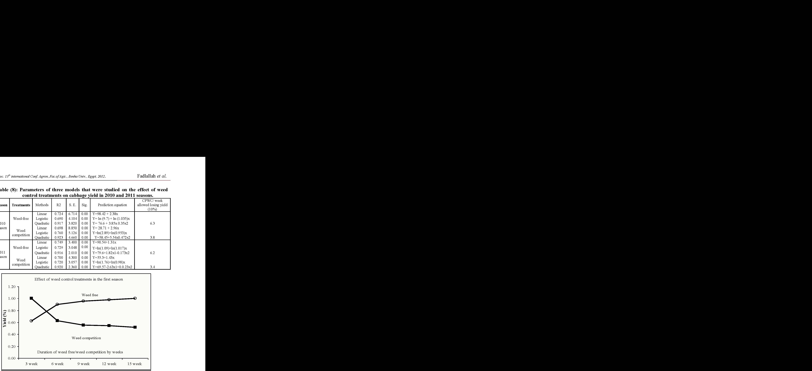

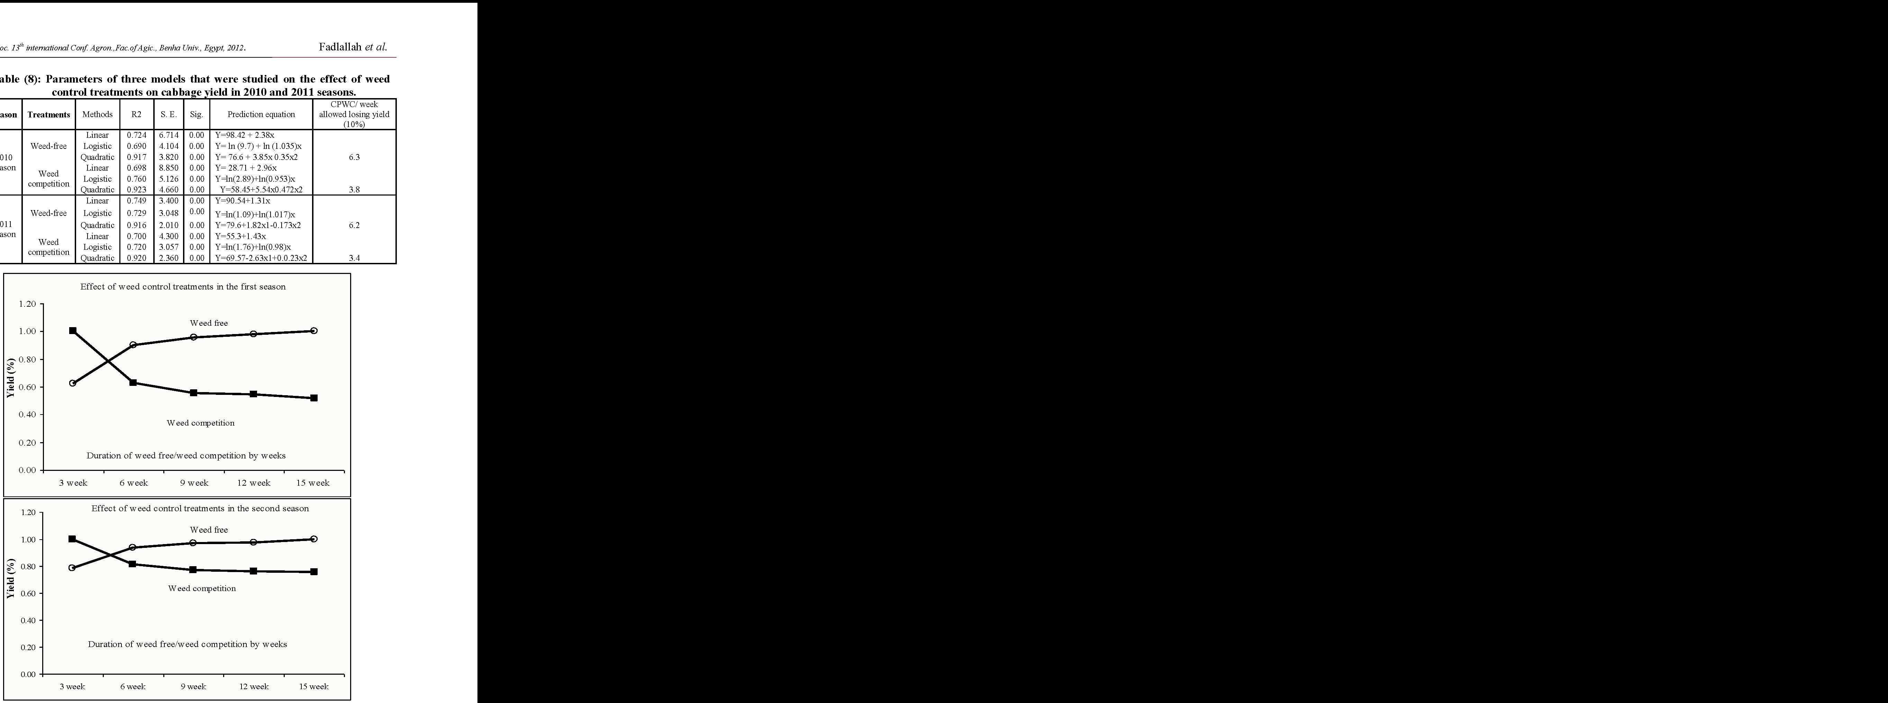

Fig (5) Effect of weed control treatments in the first season and second.
The results of coefficient of determination (R2) being 0.917 and 0.916 for weed free and being 0.923 and 0.920 for the weed competition over all treatments of the two seasons, respectively.
Data clearly present that the critical period of weed control over all studied agricultural practices according to the recommended allowed losing yield value (10 %) being 6.30 and 6.20 weeks for weed-free and being 3.75 and 3.40 weeks for weed-competition in the first and second seasons, respectively. These results showed that, the critical of weed control didn't differ more than individual agricultural practices that were studied. These accepted models had lost values of standard error of estimated compared with models and they had significant calculated if value in the two seasons. So, these models were the best of the response models tested for describing the relation between yield of cabbage to weed-free and weed competition, (Figs. 5).
CONCLUSION
In the first study, Roundup and Amex plus one hand hoeing gave the best control for annual weeds but Fusilade super more effective controlling for grassy annual weeds only. There no any residual effect for Amex and Fusilade super in cabbage leaves. So can be recommended these herbicides for control weeds in cabbage. In the second study, nine weeks cabbage required for kept weed free to obtain success cabbage yields and three weeks of weed competition without damage.
REFERENCES
Agresti, Alan (1996). An introduction to categorical Data Analysis. John Wiley and Sons, Inc.
Arora, S. and Gopal, M. (2004). Residues of pendimethalin after weed control in cabbage crop (Brassica oleracea var. capitata). Bulletin of Environmental Contamination-and Toxicology. 73(1): 106-110.
Bracy, R.P. and Parish R.L. (2003). Recommended rates of trifluralin affect direct-seeded cabbage stands. Louisiana-Agriculture. 46(1): 20
Caruso, G.; Stoffella P.J.; Cantliffe D.J. and Damato G. (2000). Relationships among planting time, chemical weed control and weed cover in cabbage (Brassica oleracea L. var. capitata). 8th International Symposium on Timing of Field Production in Vegetable Crops, Bari, Italy, 15-18 October, 1997. Acta-Horticulturae., No. 533, 229-241.
Dhiman, N. K.; Nandal T.R. and Rajender S. (2005). Effect of herbicides and their combinations on economics of cabbage production. Crop-Research-Hisar. 30(1): 73-76
Dillard, H.R.; Bellinder R.R. and Shah D.A. (2004). Integrated management of weeds and diseases in a cabbage cropping system. Crop-Protection. 23: (2): 163-168.
Dixit, A.J.; Ramteke J.R.; Thorat. S.T. and Jambhale N.D. (2005). Efficacy of herbicides in controlling weeds in cabbage. Journal-of-Maharashtra-Agricultural Universities. 30(3): 362-363.
Duncan, B. D. (1955). Multiple test range and multiple F tests. Biometrics. 11-142.
Evans, S. P.; S. Z. Knezevic; J. L. (Lindquist; C. A. Shapiro and E. E. Blankenship (2003). Nitrogen application influences the critical period for weed control in corn. Weed Sci. 51: 408-417.
Frans, R. E. and Talbert, R. (1977). Design of field experiment and the measurement and analysis of plant response. Res methods in Weed Science. Soc. Field. South. Weed Sci. Soc. USA , Aburn, Alabama.
Gomez, K. A. and A. A. Gomez (1984). Statistical procedures for agricultural research . John Wiley & Sons, Inc. New York, USA.
Hall, M. R.; C. J. Swanton and G. W. Anderson (1992). The critical period of weed control in grain corn (Zea mays). Weed Sci. 40: 441-447.
Heady, E. O. and Dillon, J. L. (1961). Agricultural production functions. Library of congress catalog card number: 60 – 11128, Iowa State University press.
Ibrahim, H.M.: Hassanein, E.E.: Al- Marsafy, H.T. and Kholosy, A.S.O (1989). Weed control in transplanted cabbage (Brassica oleracea var. capitata). Egypt. J. Agric. Res. Vol. 67: (4): 593 – 602.
Knezevic, S. Z.; S. P. Evans; E. E. Blankenship; R. C. Van Acker and J. L. Lindquist (2002). Critical periods for weed control: the concept and data analysis. Weed Sci. 50: 773-786.
Knezevic, S. Z.; S. P. Evans and M. Mainz (2003). Row spacing influences the critical timing for weed removal in soybean (Glycine max). Weed Technol. 17: 666-673.
Neter, J.; W. Wasserman and M. H. Kunter (1990). Applied linear statistical models3rd ed., IRWIN, Homewood, Boston, U.S.A.
Nguyen, T.D.; Han, E.M.; Seo, M. S. Kim, S.R. Yun, M. Y. Lee, D. M. and Lee, G. H. (2008). Amulti-residue method for the determination of 203 pesticides in rice paddies using gas chromatography/mass spectrometry. Analytica Chemica Acta 619: 67-74.
Norsworthy, J. K. and M. J. Oliverira (2004). Comparison of the critical period for weed control in wide and narrow row corn. Weed Sci. 52: 802-807.
Piper, C. S. (1950). Soil and Plant Analysis. Inter. Science Publ. INC., New York.
Qasem, J.R. and Hill T.A. (2003). Competition effects of fat-hen (Chenopodium album L.) and groundsel (Senecio vulgaris L.) on cabbage and lettuce. Dirasat Agricultural-Sciences. 30(2): 178-185.
Sanjeev, A.; Sandhu, K. S. and Ahuja, S. (2003) .Weed management through the use of herbicides in cabbage-onion relay cropping system. Annals of Biology.19: 1, 27-30.
Sanjeev, A.; Sandhu, K.S. and Ahuja, S. )2003). Efficiency of weed control in cabbage onion relay cropping system. Annals of Biology. 19: 1, 31-34.
Semidey, N.; Gonzalez A. and Aponte A. (1999). Application timing for clomazone and oxyfluorfen in transplanted cabbage. Journal of Agriculture of the University of Puerto Rico. 83: 3-4, 175-180.
Snedecor, D.W. and Cochran W. (1980). Statistical methods seventh ed., Iowa state University Press, Iowa U.S.A.
Sonnenberg, P. E. and Silva N. F. (2005). Weed interference in transplanted cabbage. Pesquisa Agropecuaria Tropical. 35(1): 9-11.
Tabachnick, B. and L. Fidell (1996). Using Multivariate Statistics, third edition. Harper Collins.
Weaver, S. E; Kropff, S.E. and R.M.W. Groeneveld (1992). Use of ecophsiological models for crop–weed interference: the critical period of weed interference. Weed science 40: 302-307.
Zimdahl, R. L. (1988). The concept and application of the critical weed free period. In Altieri, M.A & Liebmann, M., eds. Weed Management in Agroeco system: Ecological Aproaches . PP 145 -155 CRS Press. Boca Roton . Florida ,USA.
الملخص العربى
تأثير منافسة الحشائش وطرق مكافحتها على النمو والأثر المتبقى وال محصول فى الكرنب
أشرف محمد فضل الله1 أحمد مصطفى أحمد حسانين1 محمود قطب حاتم2
1- المعمل المركزى لبحوث الحشائش – مركز البحوث الز ا رعية
2- معهد بحوث البساتين – مركز البحوث الز ا رعية.
أجريتتت د ا رستتتتين )أربتتتا تجتتتارب ح يتتتة( بمحطتتتة بحتتتوث البستتتاتين بال نتتتاطر ال يريتتتة بمحاف تتتة 2010 لد ا رستتتتة كفتتتتا بعتتتتض مبيتتتتدا / 2002 و 2002 / ال يوبيتتتتة. الاولتتتتى أجتتتتر يتتتت موستتتتمى 2002 2010/ الحشتتائش ع تتى مكافحتتة الحشتتائش وأنتاجيتتة محصتتول الكرنتتب وال انيتتة أجريتت موستتمى 2002 2011 لتحديد الفتر التى يجب أن تكون الارض الية من الحشائش بعتد الشتتل ل حصتول ع تى / و 2010 اكبر محصول أو الفت ر التى تتواجد فيها الحشائش دون تأ ير ع ى المحصول.
وقد أوضحت أهم النتائج مايلى:
أولاً: التجربة الأولى.
- أد طرق مكافحة الحشائش إلتى ن تم معنتوى فتى التوزن الجتاف ل حشتائش الحوليتة وأعطت معتام تى ا رونتتد أب بمعتتدل 1 لتر/الفتتدان وأمتتيك بمعتتدل 2.2 لتتتر/الفتتدان+ عزقتتة أع تتى ان فتتاض فتتى وزن الحشائش الك ية كما كان مبيد فيوزي يد سوبر بمعدل 1 لتر/الفدان أع ى كفا فتى مكافحتة الحشتائش النجي ية الحولية ف ط.
- أد طتترق مكافحتتة الحشتتائش إلتتى زيتتاد معنويتتة فتتى قطتتر الستتاق ووزن وطتتول وقطتتر التت أ ر وعتتدد الأو ا رق ال فة وطول الساق كما أن ص معنويتا عتدد الأو ا رق الريتر لفتة وأيضتا أعطت معتام تى روانتد أب وأميك متبوعاُ بعزقة أفضل النتائج لهذه الصفا .
- بتح يل أو ا رق الكرنب تبين عدم وجود أى أ ر متب ى لمبيدى الاميك والفيوزي يد سوبر.
ثانياً: التجربة الثانية.
- أعطت معام تة إ ا زلتة الحشتائش لمتد 12 أستبوم متن شتتل الكرنتب نتتائج مشتابهة لمعام تة إ ا زلتة الحشتائش طتول الموستتتم وذلتتتة بالنستتتبة لتتتن م أوا زن الحشتتتائش الك يتتتة عريضتتتة وضتتتي ة الأوا رق وزيتتتاد محصتتتول الكرنتتتب ومكوناته فى الموسمين وبالم ل أعط معام تة تترة الحشتائش لمتد 3 أستابيا متن شتتل الكرنتب نفت النتتائج الساب ة ت ريبا .
توصتتى الد ا رستتة باستتت دام مبيتتد ا رونتتد أب بعتتد ترطيتتة نباتتتا الكرنتتب بالبلاستتتية أ نتتا التترش وكذلة مبيد أميك ع ى التربة قبل ن ل الشتتلا مضتافا إليته عزقتة لمكافحتة الحشتاش الحوليتة الك يتة أمتا مبيد فيوزي يد سوبر فيُست دم لمكافحة الحشائش النجي ية. كما توصى الد ا رسة بمكافحة الحشتائش تلال 2 أسابيا الأولى من الشتل حيث أنها الفتر المؤ ر فى منافسة الحشائش ل محصول.

