Benha university Post Graduates Faculty of Agriculture Department of Plant Protection
Final exam : (Pesticide Chemistry (1))
( 60 marks) Time allowed : 2Hours First Semester 2016/2017

Model Answer

1- Please, Answer only three Questions (15 marks- (5 Marks/ Question)

- What is the pesticide , and what are its Names?
Pesticides is any chemical that kills, controls, drives away, or modifies the behavior of a pest”.
There are different types of pesticides and a classification is offered according the target organism.
Pesticide Names
Chemical name *
The systematic Name of a Chemical Compound according to the rules of nomenclature of the International Union of Pure and Applied Chemistry as adapted for indexing in Chemical Abstracts
For example: 3,5,6-trichloro-2-pyridinyloxyacetic acid.. is a chemical name
Common Name
A generic name for a chemical compound (see the Weed Science Society of America list of herbicide nomenclature)
For example: The common name for 3,5,6-trichloro-2-pyridinoxyacetic acid.. is Triclopyr The common name is the name generally used in discussing pesticides toxicology and environmental behavior and fate
Product Name:
The trade name of a pesticide; that is the name on the container you purchase. It is also the name to which the EPA registration number is applied at the time of registration Triclopyr alone is sold as: Garlon 3A or Garlon 4
- What are the main chemical classes of pesticides?
Classification of Pesticides by Chemistry
- Inorganic pesticides *
  - Molecules do not contain carbon
    - Heavy metals – lead and arsenic
    - Copper products
    - Sulfur products
Highly toxic biocides have the ability of remaining in the environment for extended periods of time. They are generally neurotoxins and even a single dose may cause permanent damage [Cunningham et al., 2003].
- Organic pesticides *
  - Molecules contain carbon
    - May be chains or rings
1- Chlorinated hydrocarbons They are synthetic organics containing chlorine. They inhibit nerve membrane ion transport and block nerve signal transmission. They may be persistent in the environment and are subjected to bioaccumulation environment. Many have been banned or restricted throughout the world, but some continue to be actively used. They include DDT chlordane and aldrine.
2- Organophosphates Synthetic organics containing phosphorus complexes. They inhibit cholinesterase, an enzyme that regulates the peripheral nervous regulates system. Extremely toxic to mammals, birds and fish (generally 10-100 times more poisonous than most chlorinated hydrocarbons) [Cunningham et al., 2003].
They degrade easily, so their bioaccumulation is rare. Some examples are parathion, malathion, dichlorvos, dimethyldichlorovinylphophate.
3- Carbamates Derivatives of carbamic acid, they act in the same way as organophosphates and have low bioaccumulation rates. Generally toxic to bees. They include carbaryl, aldicarb, aminocarb and carbofuran.
4- Botanical Pesticides - Botanical pesticides are used to control insects,
spiders, and mites. They are rapidly degrading contact pesticides. Botanical
pesticides (e.g. natural pyrethroids) are derived from plants. Pyrethrum is
the most common of the natural pyrethroid group. Pyrethrum is extracted
from the flower heads of the chrysanthemum plant. It is a mixture of four
compounds with similar chemical structures. These compounds act by disrupting the nerve impulse as it travels down the nerve cell. If the nerve impulse is disrupted, muscles are quickly paralysed. The manufacturer often adds piperonyl butoxide to increase pesticide effectiveness. Pyrethrum is listed on pesticide product labels as the active ingredient “pyrethrins”.
5- Synthetic Botanical Insecticides - Synthetic pyrethroids (e.g., resmethrin and permethrin) are used as contact or stomach insecticides. They are man-made equivalents of natural pyrethrums. They show similar pesticidal characteristics. Piperonyl butoxide is often added to enhance effectiveness. Applications are made to foliage when pests appear.
6- Fumigants Generally small molecules such as carbon tetrachloride, carbon disulfide, ethylene dichloride, ethylene dibromides that gasify easily and penetrate rapidly into some materials. They are used to sterilize soil and prevent degradation of stored grain. These compounds are very dangerous for workers, and their use has been severely restricted or banned. [Cunningham et al., 2003]
- What are Biopesticides, and what are its classes?
Biopesticides are certain types of pesticides derived from such natural materials as animals, plants, bacteria, and certain minerals. For example, canola oil and baking soda have pesticidal applications and are considered biopesticides. As of April 2016, there are 299 registered biopesticide active ingredients and 1401 active biopesticide product registrations.
- Biochemical pesticides are naturally occurring substances that control pests by non-toxic mechanisms.
- Microbial pesticides consist of a microorganism (e.g., a bacterium, fungus, virus or protozoan) as the active ingredient.
- Plant-Incorporated-Protectants (PIPs) are pesticidal substances that plants produce from genetic material that has been added to the plant. For example, scientists can take the gene for the Btpesticidal protein and introduce the gene into the plant's own genetic material. Then the plant, instead of the Bt bacterium, manufactures the substance that destroys the pest. The protein and its genetic material, but not the plant itself, are regulated by EPA.
- Mode of action of oils as pesticides?
2-" Organophosphates (OPs) are a class of insecticides, several of which are highly toxic." discus that and what are the relationship between The Chemistry of organophosphorus compounds and their toxicity ? (15 Marks)
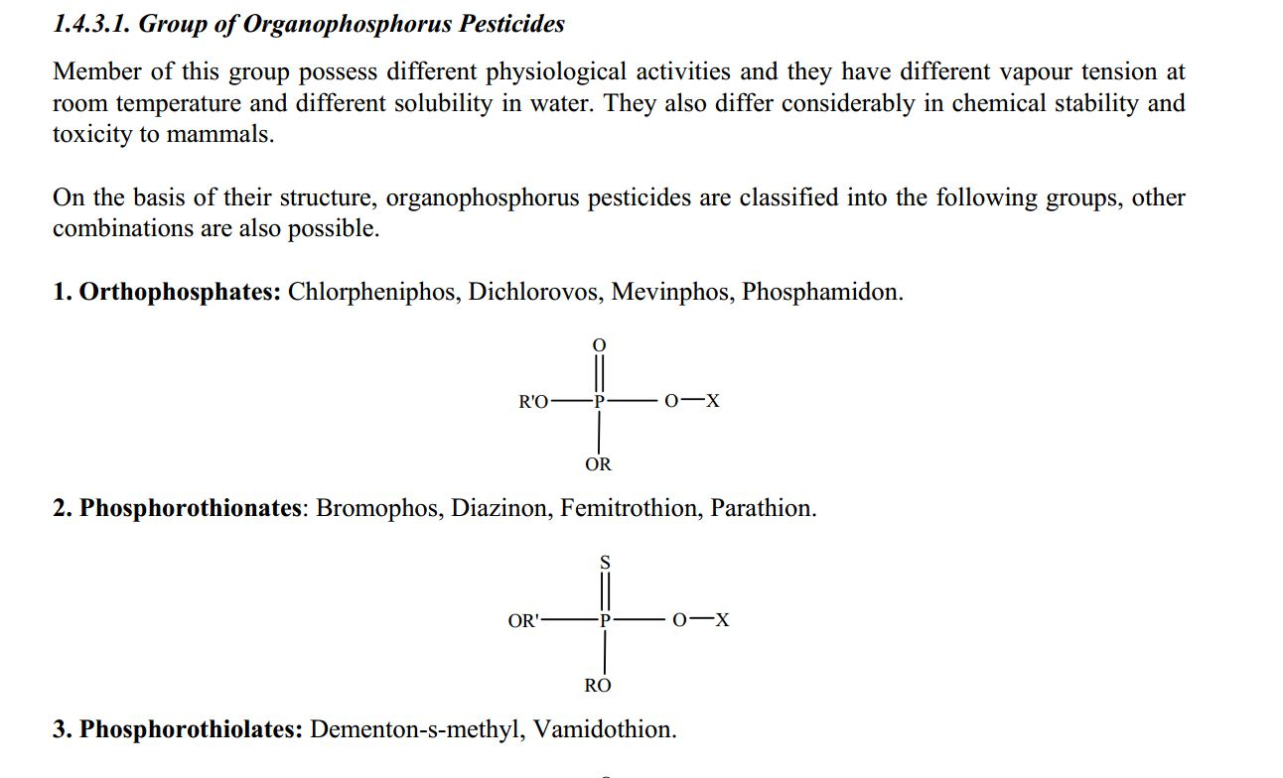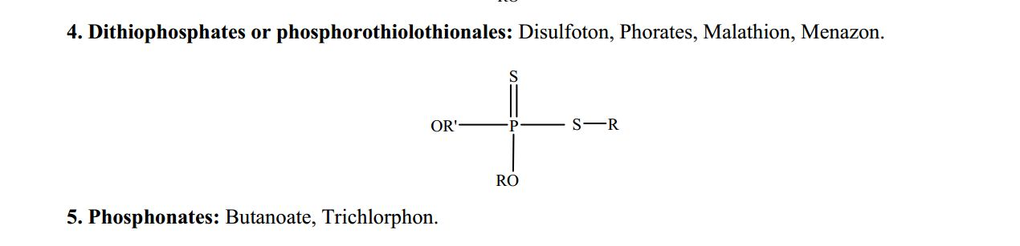
1. Group I: These compounds have low chemical stability and solubility in water. They are rapidly hydrolysed in water. They are used as contact insecticide (Mevinphos, Tetraethylpyrophosphates (TEPP), and Tetrachlorvenphos).
2. Group II: These compounds have moderate to high chemical stability. Usually, they have low solubility in water but more soluble in oil. Theyare persistent, contact or quasi-systemic (partly systemic and partly contact) in nature (Malathion, Methylparathion, Fenintrothion, Diazinon).
3. Group III: These compounds have moderate to high chemical stability. Their oil/water partition coefficient enables them to enter in the plant and to be translocated in them. These are systemic pesticides and have to be activated before reaching to the site of contact (Phorate, Dimethoate, Disulpton, and Formothion).
4. Group IV: These compounds have high vapour pressure and low chemical stability and because of these feature they are used as fumigants (Dichlorovos, Sulfotep).
5. Group V: These compounds are suitable for formulation as granule for soil application (Chlorfenvinphos, Bromophos).
6. Group VI: These compounds are suitable for surface application (Cumaphos, Fenchlorphos).
3- Please, Answer the following Questions (30 Marks) A) What is meant by the following terms: (answer seven only) (14 Marks)
Chemosterilant groups a chemical compound that causes reproductive sterility in an organism. They may be used to control pest populations by sterilizing males.A chemosterilant is any chemical compound used to control economically destructive or disease-causing pests (usually insects) by causing temporary or permanent sterility of one or both of the sexes or preventing maturation of the young to a sexually functional adult stage
Proinsecticidal organophosphates The parent compound and/or metabolites of some pesticides have multiple targets, requiring identification of the causal agents and their modes of action. This review considers a few of the author’s observations in the past six decades, some solved and others still puzzling. It illustrates that a new substituent combination not only confers specific chemical and physical properties to a class of compounds but often yields metabolites with a surprising variety of biological activities. Examples considered include proinsecticides, procyclic phosphates, CYP inhibitors as synergists,
Wetting agents are substances that reduce the surface tension of water to allow it to spread drops onto a surface, increasing the spreading abilities of a liquid. Lowering the surface tension lowers the energy required to spread drops onto a film, thus weakening the cohesive properties of the liquid and strengthening its adhesive properties. One example of how wetting agents work is in the formation of micelles. Micelles consist of hydrophilic heads forming an outer layer around lipophilic tails. When in water, the micelles' tails can surround an oil droplet while the heads are attracted to the water. - Controlled Release Formulations is a term referring to the presentation or delivery of compounds in response to stimuli or time. This term is most widely used within the pharmaceuticals industry, but is also used in other areas including agriculture, cosmetics and personal care, and food science.
Baits Food or other lure placed on a hook or in a trap and used in the taking of fish, birds, or other animals.
Stickers a type of label: a piece of printed paper or plastic with pressure sensitive adhesive on one side. They can be used for decoration, depending on the situation. They can come in many different shapes, sizes and colours and are put on things such as lunchboxes, in children's rooms, on paper, lockers, notebooks and so on. Some people collect and trade stickers with other collectors.[1]Temporary name tags are usually stickers.
Surfactants compounds that lower the surface tension (or interfacial tension) between two liquids or between a liquid and a solid. Surfactants may act as detergents, wetting agents, emulsifiers, foaming agents, and dispersants.
B) What is the difference between each of the following: (answer four only) (16 Marks)
1- Synergism is the combination of two or more things that creates an effect which is greater than the sum of each separately. and Potentiation is a reagent that enhances sensitization of an antigen
2- Atractants a substance (as a pheromone) that attracts specific animals (as insects or individuals of the opposite sex) and Repellents is a substance applied to skin, clothing, or other surfaces which discourages insects (and arthropods in general) from landing or climbing on that surface. Insect repellents help prevent and control the outbreak of insect-borne (and other arthropod-bourne) diseases such as malaria
3- Impregnated dust and Straight dust
4- Emulsifiable Concentrates An emulsifiable concentrate formulation usually contains a liquid active ingredient, one or more petroleum-based solvents (which give EC formulations their strong odor), and an agent that allows the formulation to be mixed with water to form an emulsion. ECs are among the most versatile formulations. and Emulsions occurs when one liquid is dispersed (as droplets) in another liquid. Each liquid retains its original identity. Some degree of agitation generally is required to keep the emulsion from separating. Emulsions
usually have a milky appearance.

Best wishes and good luck
Prof. Dr: Safaa Halawa

