Agricultural Biochemistry Dept. May: 2016
Advanced Lipid chemistry ( 60 marks) Time: 2 hours
Advanced Lipid chemistry

Model Answer
- Biosynthesis of cholesterol

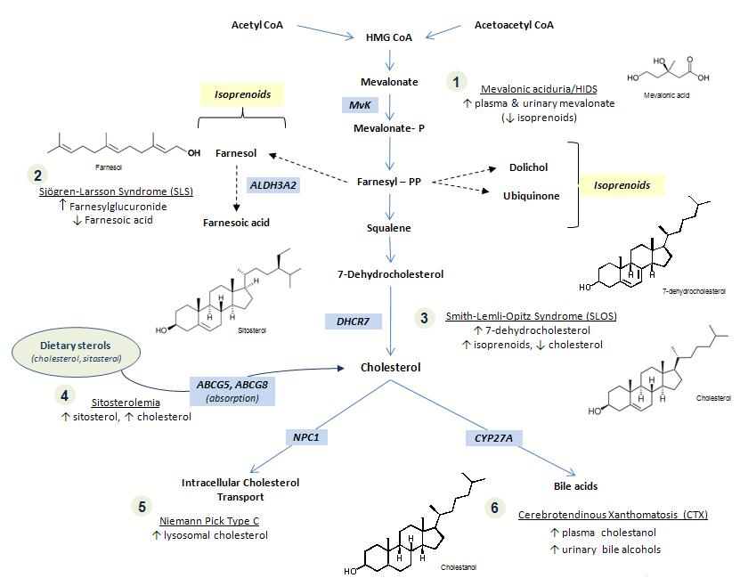

B- Oxidation of saturated fatty acid ( stearic acid ).

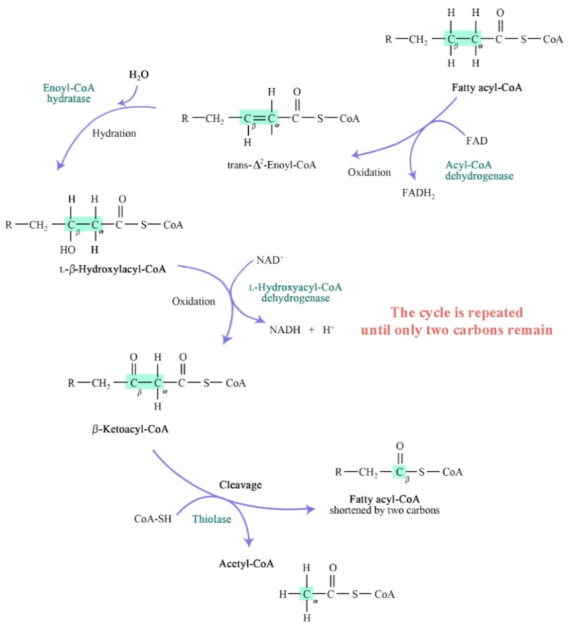

Biosynthesis of Palmatic acid

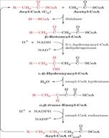

Biosynthesis of phospholipid
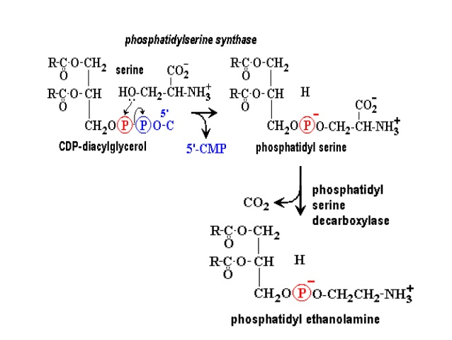

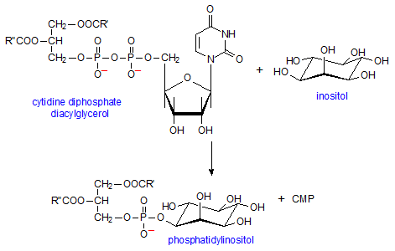
Second Question :- (14 marks)

Choose the correct answer

- B
- D
- D
- B
- C
- D
- C
- C
- C
- A
- A
- B
- C
- c

